**A**

**PROJECT REPORT**

**ON**

**“Desktop Application”**

#### “Clinic Management System”

Designed By

**Mr. Mitesh Pravin Mithbavkar**

Submitted To

**University Of Mumbai**

**In the Partial Fulfillment of**

**B.Sc. Computer Science (Third year)**

**Under Guidance of**

**Asst. Prof. P. N. Talankar.**

Through

**THE HEAD,**

**DEPARTMENT OF COMPUTER SCIENCE**

**S.R.M. COLLEGE, KUDAL.**

**2020-2021**

**DECLARATION**

**To,**

**The Head,**

**Department of Computer Science,**

**S. R. M. College, Kudal.**

**Respected Sir,**

**I undersigned, hereby declare that the project on “Clinic Management System” is developed under the guidance of our lecturer Prof. P.N.Talankar.**

**The conclusion in this report is based on the data, which is collected by me. I am declaring that this is my original work. I have not copied any materials, which are useful to my work, or other reports that are submitted to the S. R. M. COLLEGE, KUDAL this year.**

**I do undersign that if my work is found to be copied, then I am liable to punishment as per the university rule.**

**DATE:**

**PLACE: KUDAL. (Mr. Mitesh Pravin Mithbavkar)**

|  |  |
| --- | --- |
| K.M.S.P. MANDAL’S  SANT RAWOOL MAHARAJ MAHAVIDYALAYA,  KUDAL.  (NAAC ACCREDITATION “B” GRADE) |  |

**CERTIFICATE**

**This is certify that Mr. Mitesh Pravin Mithbavkar has completed her work on Project Report Titled,**

**“Clinic Management System”**

**As per the syllabus prescribed for T. Y. BSc (Computer Science) of Mumbai University, Mumbai. It is also certified that this is her own work completed during academic year 2020 – 2021. The work done is satisfactory and is presented as per the specifications.**

**PROJECT GUIDE EXTERNAL EXAMINIER HEAD OF DEPARTMENT**

**DATE : PLACE : KUDAL.**

**Index**

|  |  |  |
| --- | --- | --- |
| **Sr. No.** | **Title** | **Page. No.** |
| **1.** | **Introduction** |  |
| **1. Organizational Overview** | **7** |
| **2. Description of System** | **8** |
| **3.Limitations of system** | **9** |
| **4. Proposed system and its advantages** | **10** |
| **5. Stack Holder** | **11** |
|  | **6.Gantt Chart** | **12** |
| **2.** | **Requirement Specification** |  |
| **1. Requirement Gathering** | **14** |
| **2. Requirement Specification** | **15** |
| **3. Technologies Used** | **16** |
| **3.** | **System Design** |  |
| **1. E-R-Diagram** | **18** |
| **2. Use Case Diagram** | **20** |
| **3. Activity Diagram** | **22** |
| **4. Class Diagram** | **24** |
| **5. Object Diagram** | **26** |
|
| **4.** | **System Tables** | **29** |
| **5.** | **Code Implementation** |  |
| **1.Validation** | **32** |
| **2.Program listing** | **34** |
| **6.** | **Results** |  |
| **1. Screen Shots** | **95** |
| **7.** | **System Implementation** |  |
| **8.** | **Conclusion and Future scope** | **103** |
| **9.** | **References** | **104** |

**INTRODUCTION**

**Organizational Overview**

**Project Name:**

**Hospital Management System**

**Objective:**

* + - **To Make clinic functionality managed easily**
    - **To Maintain record of patient and treatment and also**
    - **there doctor medicine records**
    - **To take blood test and stored there records**
    - **To add short notes**
    - **Searching Functionality.**

**Interaction Of System:**

* + - **Doctor**
    - **Patient**

**2.Description Of the System**

* **It is Desktop application**
* **This System Used to stored patient details, receipt and clinic**
* **Medicine details so that doctors easily can findout.**
* **This system is used to maintain an easy relation between**
* **Doctors and patient**

**3.Limitations of the System**

* **It can be only used by system user**
* **If the user are increase then this part is not include yet**
* **All work done by manually**

**4.Proposed System and It’s Advantages**

**Proposed System:**

**Clinic Management System:**

1. **There is no such system in small clinic**
2. **Reasons of this system are:**
3. **Doctors Medicine details also stored**
4. **Receipt can be created.**

* **If Patient visited to hospital then next time they don’t**
* **Need to give their details because details are stored**
* **In system**

**Advantage:**

* **System can be used for small clinic in town**
* **To store Details of patient and Medicine History**
* **doctors can also take blood test and add test report**

**5.Statkeholders**

**1.Admin:**

* **Admin is the doctor or there one staff member who is doctor responsible to add Patient details and also add medicine details to maintain all records**

**2.Project Developer:**

* **Project developer is responsible for developing project,**
* **Coding, modifying etc.**

**3.Project Tester:**

* + - **The Person who is test whether the project is user friendly And fulfill requirement of doctors or not**

**Gantt Chart**

**Phases Proposed Time**

**Actual Time**



**Preliminary Investigate**



**System Analysis**



**System Coding**



**System Design**



**Testing & Validation**



**5 sept 15 sept 15oct 2 nov 15 nov**

**REQUIREMENT SPECFICATION**

**Requirement gathering**

**A. Fact finding Technique:**

**To study the system we require facts. Fact is also termed as data or information. A specific method use for collecting a data is also called fact finding technique.**

**Interview, questionnaires, record review, observation are the different fact finding technique use by analyst. Analyst uses more than one technique for collecting correct and accurate data.**

**Interview:**

**This technique use to collecting information from individual or from group.**

**Interview Techniques:**

* **Structured Interview:**

**In this type of technique fixed format interview in which all question are prepared beforehand and put in the same order to each interview. Although this style lacks the free flow a friendly conversation. It provides a precision and reliability require in certain situation. In this type of techniques interview period may be short. It is also called direct interview.**

* **Unstructured Interview:**

**In this type of technique different type of question are asked and there are specific area. Interview without any set format but in which interviewer may have some key questions formulated in advanced. Unstructured interview allow question based on interview’s response and proceed like friendly. Is also called as non-directive interview.**

**Requirement Specification**

**1. Functional Requirement:**

* **Add users:**
* **Add Patient to the system**
* **Add medicine details to the system**
* **Add critical Patient**
* **Add Blood test**
* **Add Notes**
* **Print Prescription:**
  + - **Give the Receipt the user**
* **Stored Details**
  + - **Shows All record we are stored like patient, medicine**

**2. Non-functional Requirement:**

* **User identification:**
* **System requires user to identify him/her using user id.**
* **Login ID:**
* **Any user who uses the system shall have an username and password.**
* **Modification:**
* **Any modification (insert and update) for database shall be synchronized and done by user.**

**Technologies used**

**Software :**

* **Front End : HTML, CSS, BOOTSRTAP**
* **Back End : Djanogo, Sqlite, Javascript**

**Hardware :**

* **Processor : Intel Core i3**
* **Memory : 8 GB RAM**
* **Storage : 1TB Hard Disk Space**

**Tools :**

* **Vs Code**
* **Microsoft Office Word**
* **Chrome**

**SYSTEM DESIGN**

**ENTITY RELATIONSHIP DIAGRAM**

**Entity – Entities are person, places, events, objects or concepts.**

**Relationship – a relationship is a naturally occuring association among entities.**

**Types of Relationships –**

1. **Mandatory Relationship.**
2. **Optional Relationship.**
3. **Binary Relationship.**
4. **Ternary Relationship.**
5. **Unary Relationship.**

**The traditional approach places a great deal of emphasis on data storage requirements for the new system. The model used to define the data storage requirements is called the Entity Relationship Diagram.**

**Rectangles represents the data entities.**

**Lines connecting the rectangles show relationship among the data entities.**

**ER Diagram is the high level conceptual diagram, which is based on the perception of real world that consist of set of basic objects called entities.**

**So objects of ER Model are,**

1. **Entity Set**
2. **Relationships**
3. **Attributes**

**Entity is basic object of ERD, which is thing in real world with an interdependent existence. i.e. it is distinguishable from other objects.**

**Among entities relationship is shown. Relationship is of type one-one, one-many, many-one, many-many. It is also called Cardinality.**

**Each entity is described by set of properties called Attributes.**

**Entity Relationship Diagram**

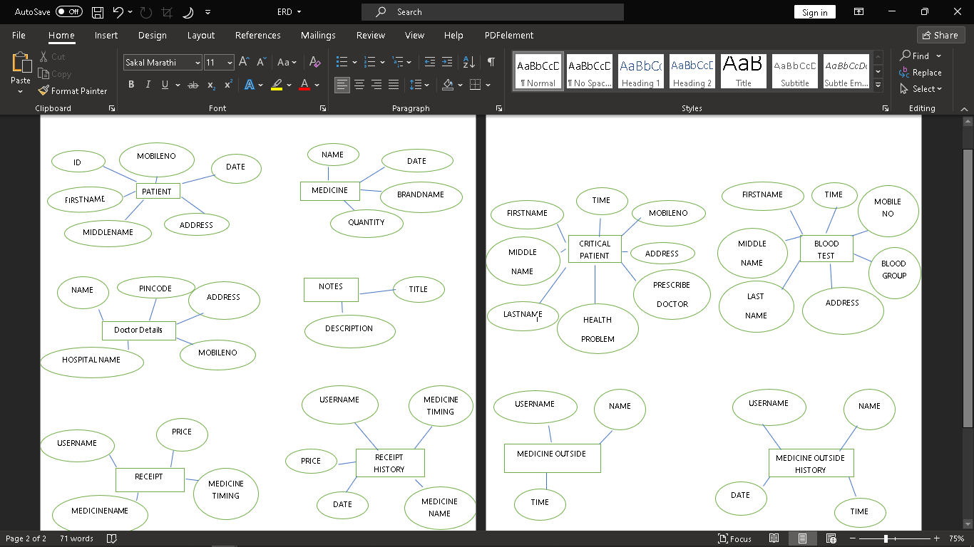

**USE CASE Diagram**

**Use case describes the behavior of a system from a user’s standpoint by using actions & reactions. They allow the definition of the system’s boundary & the relationships between the system & the environment.**

**Use cases associated with object-oriented technique provide a complete approach for the whole project lifecycle, from specification to implementation. A use case corresponds to a specific king of system use. It is an image of a system’s functionally, which is triggered in response to the simulation of an external actor.**

**How to draw use case diagram -**

1. **Identify actors of the system.**
2. **After identifying the role of the actors next developed the list of flow of activities as the starting point for identifying various scenarios.**

**Symbols used for use case diagram:**

* Stick Person
* Use Case
* Connection Line
* Automation Boundary

**ADMIN**

**Activity DIAgRAm**

**An activity diagram is a variant of state chart diagram organized according to actions, and mainly targeted towards representing the internal behavior of a**

**method or a use case. An activity is represented by a rounded rectangle.**

**How to develop activity diagram:**

**1] Identify swim length.**

**2] Identify input message.**

**3] Describe message from external actor to system using message notation.**

**4] Identify and add any special condition on the input messages including iteration**

**and true or false condition.**

**5] Identify and add the output return messages.**

**Symbols used for Activity Diagram :**



**For Doctor or Admin:**

**login**

**Verify login**

**no**

**yes**

**Authentication**

**Patient**

**prescription**

**Blood test**

**Critical patient**

**Medicine**

**notes**

**Receipt print and Add**

**Add**

**Searching**

**show**

**Class Diagram**

**Class diagrams express ,in a general way ,the static way ,the static structure of a system, in terms of classes and relationships between those classes .Just as a class describes a set of objects ,an association describes a set of links ;objects are class instances ,and links are association instances.**

**The rectangles that act as a symbol for the class may also contain a stereotype and properties. UML defines the following class stereotypes.**

|  |  |
| --- | --- |
| **Stereotype** | **Definition** |
| **<<Signal >>** | **A notable event that triggers a transaction within a state machine.** |
| **<<Interface>>** | **A description of visible operations.** |
| **<<Metaclass >>** | **The class of a class, as in small talk.** |
| **<<Utility>>** | **A class reduced to the concept of module and which cannot be Instantiated.** |

**How to draw class diagram:**

**1] Class diagrams are most popular UML diagrams used for construction of software application. So it is very important to learn the drawing procedure of class diagram.**

**2] Class diagrams have lot of properties to consider while drawing but here the diagram will be considered from a top level view.**

|  |
| --- |
| **Medicine** |
| **+name:charfeild**  **+brandname:charfeild**  **+quantity:intergerfeild**  **+price:integerfeild** |

|  |
| --- |
| **Patient** |
| **+Firstname:charfeild +middlename:charfeild**  **+Lastname: charfeild**  **+Address: charfeild**  **+Mobileno:integerfeild**  **+Date:datefeild** |

|  |
| --- |
| **Add()**  **Show Details()**  **Searching()**  **Login()** |

|  |
| --- |
| **Critical patient** |
| **+Firstname:charfeild +middlename:charfeild**  **+Lastname: charfeild**  **+Address: charfeild**  **+Mobileno:integerfeild**  **+Date:datefeild**  **+Presecribedoctor:charfeild**  **+Healthproblem:charfeild**  **+Date:datefeild** |

|  |
| --- |
| **Notes** |
| **+Title:**  **charfeild**  **+dercription:**  **charfeild** |

|  |
| --- |
| **Blood Test** |
| **+Firstname:charfeild +middlename:charfeild**  **+Lastname: charfeild**  **+Address: charfeild**  **+Mobileno:integerfeild**  **+Date:datefeild**  **+Presecribedoctor:charfeild**  **+Healthproblem:charfeild**  **+Date:datefeild** |

**object DIAgRAM**

**Object diagrams, or instance diagram, illustrate objects and links. As in the case of class diagrams, object diagrams represent the static structure .The notation used for object diagrams is derived from that of class diagrams; elements that are instances are underlined.**

**Object diagrams are primarily used to show a context –before or after an interaction, for example. However, they are also used to aid the understanding of complex data structures, such as recursive structure.**

**How to draw object diagram:**

**1] Analyze the system and decide which instance are having important data and**

**association.**

**2] Consider only those instances which will cover those functionality.**

**3] Object diagram should have meaningful name indicate its purpose.**

**4] Association among object should be clarified.**

**5] Add proper notes at points where more clarity is required.**

**Symbols used for object Diagram:**



-Connection Line (Used to represent the association between two objects).

Is a

Is a

-Triangle (Used to Generalization of object)

-Triangle (Used to Specialization of object)

|  |  |
| --- | --- |
| :**Doctor**  **(Admin)** | |
|  | |
|  |  |
| **:Patient** | |
| |  | | --- | |  | |  | | |

**system Tables**

**1)Patient Details:**

|  |  |
| --- | --- |
| **Patient firstname** | **Charfeild(max_length=70)** |
| **Patient middlename** | **Charfeild(max_length=70)** |
| **Patient lastname** | **Charfeild(max_length=70)** |
| **Patient Address** | **Charfeild((max_length=70)** |
| **Patient Mobileno** | **Intergerfeild()** |
| **date** | **DateFeild** |

**2)Prescription:-**

* **For medicines which are present in clinic**

|  |  |
| --- | --- |
| **Username(Patient**  **Full name)** | **Charfeild(max_length=70)** |
| **MEDICINE NAME** | **Charfeild(max_length=70)** |
| **TIMING** | **Charfeild(max_length=70)** |
| **PRICE** | **Charfeild(max_length=70)** |

* **Outside Medicine Table**

|  |  |
| --- | --- |
| **username** | **Charfeild(max_length=70)** |
| **outsidemedicinename** | **Charfeild(max_length=70)** |
| **outsidemedicinetime** | **Charfeild(max_length=70)** |

* **Outside Medicine History**

|  |  |
| --- | --- |
| **username** | **Charfeild(max_length=70)** |
| **outsidemedicinename** | **Charfeild(max_length=70)** |
| **outsidemedicinetime** | **Charfeild(max_length=70)** |
| **date** | **Datefeild()** |

* **Receipt Histrory**

|  |  |
| --- | --- |
| **Username(Patient**  **Full name)** | **Charfeild(max_length=70)** |
| **MEDICINE NAME** | **Charfeild(max_length=70)** |
| **TIMING** | **Charfeild(max_length=70)** |
| **PRICE** | **Charfeild(max_length=70)** |
| **date** | **Datefeild()** |

**3)MEDICINE STORE**

|  |  |
| --- | --- |
| **MEDICINE NAME** | **Charfeild(max_length=70)** |
| **BRAND NAME** | **Charfeild(max_length=70)** |
| **PRICE** | **Charfeild(max_length=70)** |
| **QUANTITY** | **Charfeild(max_length=70)** |
| **date** | **Datefeild()** |

**4)Note App**

|  |  |
| --- | --- |
| **Title** | **Charfeild(max_length=70)** |
| **description** | **Charfeild(max_length=70)** |

**5)Blood Test:**

|  |  |
| --- | --- |
| **Patient firstname** | **Charfeild(max_length=70)** |
| **Patient middlename** | **Charfeild(max_length=70)** |
| **Patient lastname** | **Charfeild(max_length=70)** |
| **Address** | **Charfeild((max_length=70)** |
| **bloodgroup** | **Charfeild((max_length=70)** |
| **Mobileno** | **Intergerfeild()** |
| **Date** | **DateFeild** |

**6)Doctor Table**

|  |  |
| --- | --- |
| **Doctor name** | **Charfeild(max_length=70)** |
| **Doctor Address** | **Charfeild(max_length=70)** |
| **Doctor mobilno** | **IntegerFeild()** |
| **hospitalname** | **Charfeild(max_length=70)** |
| **pincode** | **Charfeild(max_length=70)** |

**7)Critical Patient:**

|  |  |
| --- | --- |
| **Patient firstname** | **Charfeild(max_length=70)** |
| **Patient middlename** | **Charfeild(max_length=70)** |
| **Patient lastname** | **Charfeild(max_length=70)** |
| **Patient_address** | **Charfeild((max_length=70)** |
| **Patient_mobileno** | **ntergerfeild()** |
| **prescribedoctor** | **Intergerfeild()** |
| **healthproblem** | **Charfeild((max_length=70** |
| **Date** | **DateFeild** |

**CODE IMPLEMENTATION**

**1.Validation**

**While any application can be designed with sound logic and good technology and deliver high performance with accuracy, some errors could still creep into it. This could be due to wrong inputs by users. While the programmer may have taken care of all the exception it could cause a loss of business good will if a customer is confronted with an error message after he has enter a valid “please enter a valid” or so on.**

**Login Page Validation**

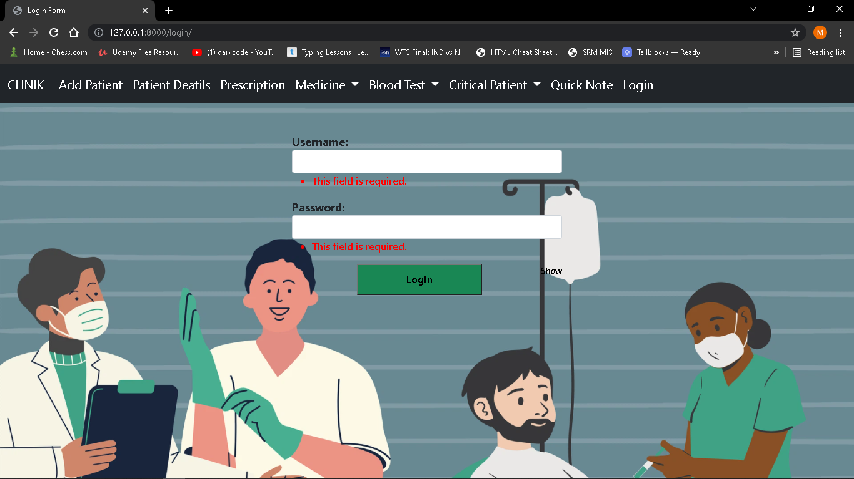

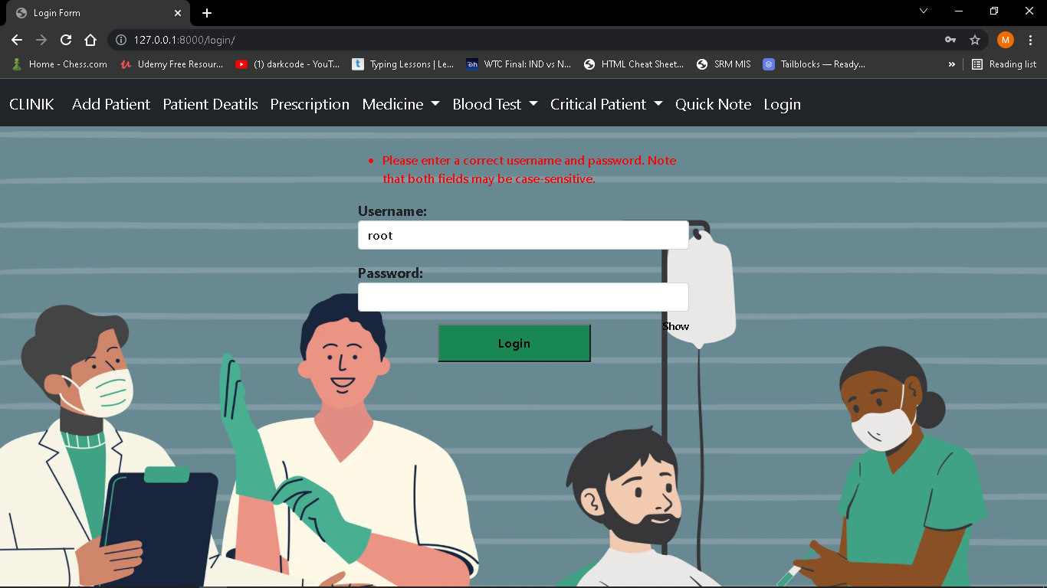

**Contact Validation**

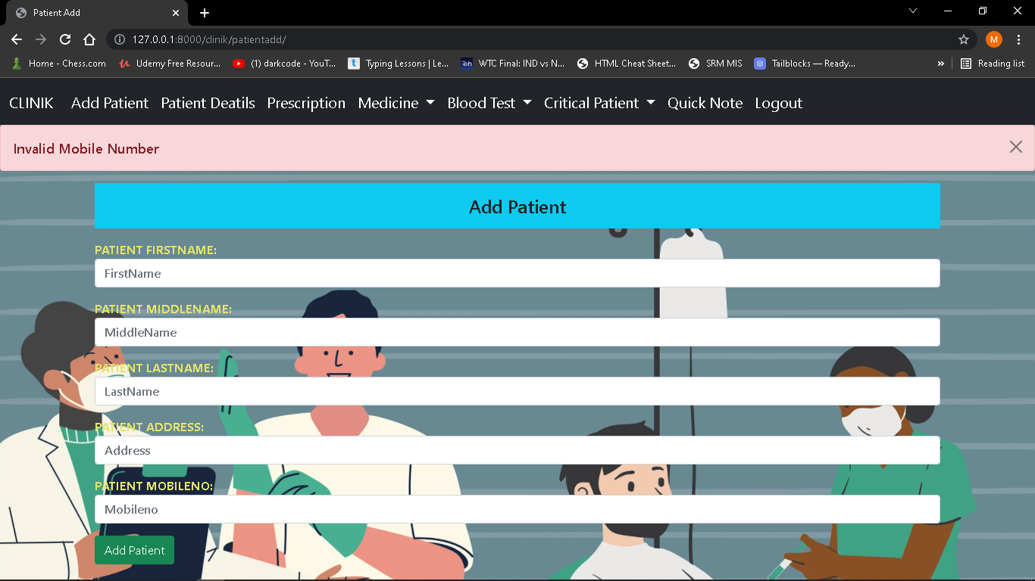

**Program Listing**

**basic.html**

<!doctype html>

{% load static %}

<html lang="en">

<meta charset="utf-8">

<head>

  <!-- Required meta tags -->

  <meta name="viewport" content="width=device-width, initial-scale=1">

  <link rel="stylesheet" href="/static/app/css/style.css">

  <link rel="stylesheet" href="/static/app/js/showbutton.js">

  <!-- Bootstrap CSS -->

  <link href="https://cdn.jsdelivr.net/npm/bootstrap@5.1.1/dist/css/bootstrap.min.css" rel="stylesheet"

    integrity="sha384-F3w7mX95PdgyTmZZMECAngseQB83DfGTowi0iMjiWaeVhAn4FJkqJByhZMI3AhiU" crossorigin="anonymous">

  <title>{%block title%}{% endblock title%}</title>

  {% block css %}

  {% endblock css %}

  <style>

    .body{

      background-image: url('/static/app/img/hospital.png');

      background-repeat: no-repeat;

      background-size: cover;

      opacity: 1;

    }

    .nav-link:hover{

      background-color: rgb(141, 132, 197);

      border-radius: 10px;

    }

    .navbar{

      font-size: 20px ;

    }

    .log{

      font-size: large;

      font-weight: 500;

      text-transform: capitalize;

    }

    </style>

</head>

<body class="body">

  <nav class="navbar navbar-expand-lg navbar-dark bg-dark">

    <div class="container-fluid">

      <a class="navbar-brand" href="/clinik/">CLINIK</a>

      <button class="navbar-toggler" type="button" data-bs-toggle="collapse" data-bs-target="#navbarSupportedContent" aria-controls="navbarSupportedContent" aria-expanded="false" aria-label="Toggle navigation">

        <span class="navbar-toggler-icon"></span>

      </button>

      <div class="collapse navbar-collapse" id="navbarSupportedContent">

        <ul class="navbar-nav me-auto mb-2 mb-lg-0">

          <li class="nav-item"></li>

            <a class="nav-link active" aria-current="page" href="/clinik/patientadd/">Add Patient</a>

          </li>

          <li class="nav-item">

            <a class="nav-link active" href="/clinik/patientdetails/">Patient Deatils</a>

          </li>

          <li class="nav-item">

            <a class="nav-link active" href="/clinik/rprint/">Prescription</a>

          </li>

          <li class="nav-item dropdown">

            <a class="nav-link dropdown-toggle active" href="#" id="navbarDropdown" role="button" data-bs-toggle="dropdown" aria-expanded="false">

              Medicine

            </a>

            <ul class="dropdown-menu" aria-labelledby="navbarDropdown">

              <li><a class="dropdown-item " href="/clinik/medicineadd/">Add</a></li>

              <li><a class="dropdown-item " href="/clinik/medicinedetails/">Details</a></li>

              <li><a class="dropdown-item" href="/clinik/history/">History</a></li>

              <li><hr class="dropdown-divider"></li>

            </ul>

          </li>

          <li class="nav-item dropdown">

            <a class="nav-link dropdown-toggle active" href="#" id="navbarDropdown" role="button" data-bs-toggle="dropdown" aria-expanded="false">

              Blood Test

            </a>

            <ul class="dropdown-menu" aria-labelledby="navbarDropdown">

              <li><a class="dropdown-item " href="/clinik/bd/">Add</a></li>

              <li><a class="dropdown-item " href="/clinik/bd1">Test Report  </a></li>

              <li><hr class="dropdown-divider"></li>

            </ul>

          </li>

          <li class="nav-item dropdown">

            <a class="nav-link dropdown-toggle active" href="#" id="navbarDropdown" role="button" data-bs-toggle="dropdown" aria-expanded="false">

              Critical Patient

            </a>

            <ul class="dropdown-menu" aria-labelledby="navbarDropdown">

              <li><a class="dropdown-item " href="/clinik/cpatientadd/">Add</a></li>

              <li><a class="dropdown-item " href="/clinik/cpatientdetails">Patient Details</a></li>

              <li><hr class="dropdown-divider"></li>

            </ul>

          </li>

          <li class="nav-item">

            <a class="nav-link active" href="/clinik/notes">Quick Note</a>

          </li>

        {% if not request.user.is_authenticated %}

          <li class="nav-item "></li>

            <a class="nav-link active " aria-current="page" href="/login/">Login</a>

          </li  >

          {% else  %}

          <li class="nav-item ">

            <a class="nav-link active" aria-current="page" href="/logout/">Logout</a>

          </li>

        {% endif %}

        </ul>

        {% block search %}

        {% endblock search %}

      </div>

    </div>

  </nav>

  {% if messages %}

  {% for i in messages %}

  <div class="alert alert-{{i.tags}} alert-dismissible fade show" role="alert">

    <div class="log">

      {{i.message}}

    </div>

    <button type="button" class="btn-close" data-bs-dismiss="alert" aria-label="Close"></button>

  </div>

  {% endfor %}

  {% endif %}

        {% block content%}{%endblock content%}

        <!-- <footer class="bg-light text-center text-lg-start">

          Copyright

          <div class="text-center p-3" style="background-color: rgba(0, 0, 0, 0.2);">

            © 2020 Copyright:

            <a class="text-dark" href="https://mdbootstrap.com/">MDBootstrap.com</a>

          </div>

         -->

        <!-- Optional JavaScript; choose one of the two! -->

        <!-- Option 1: Bootstrap Bundle with Popper -->

        <script src="https://cdn.jsdelivr.net/npm/bootstrap@5.1.1/dist/js/bootstrap.bundle.min.js"

          integrity="sha384-/bQdsTh/da6pkI1MST/rWKFNjaCP5gBSY4sEBT38Q/9RBh9AH40zEOg7Hlq2THRZ"

          crossorigin="anonymous"></script>

        <!-- Option 2: Separate Popper and Bootstrap JS -->

        <!--

    <script src="https://cdn.jsdelivr.net/npm/@popperjs/core@2.9.3/dist/umd/popper.min.js" integrity="sha384-W8fXfP3gkOKtndU4JGtKDvXbO53Wy8SZCQHczT5FMiiqmQfUpWbYdTil/SxwZgAN" crossorigin="anonymous"></script>

    <script src="https://cdn.jsdelivr.net/npm/bootstrap@5.1.1/dist/js/bootstrap.min.js" integrity="sha384-skAcpIdS7UcVUC05LJ9Dxay8AXcDYfBJqt1CJ85S/CFujBsIzCIv+l9liuYLaMQ/" crossorigin="anonymous"></script>

    -->

</body>

</html>

**home.html**

{% extends 'app/basic.html' %}

{% load static %}

{%block title %}Home Page{% endblock title %}

{% block css %}

{% endblock css %}

{% block content %}

{% endblock content %}

**logininfo.html**

{% extends 'app/basic.html' %}

{% load static %}

{%block title %}Login Form{% endblock title %}

{% block css %}

<style>

    .errorlist{

        color:red;

        font-weight: 600;

    }

    .form-control{

        font-weight: 600;

    }

    label{

        font-weight: 500;

        font-size: large;

    }

    .button{

        height: 50px;

        width: 200px;

    }

    .showpasswordtoggle{

        cursor: pointer;

        transition: all;

        float: right;

        font-weight: 600;

        color: black;

    }

    .showpasswordtoggle:hover{

        font-weight: 700;

        transform: scale(1.2);

        color: rgb(218, 106, 32);

    }

</style>

{% endblock css %}

{% block content%}

<div class="container my-3 py-3 col-md-4">

    <form method="post" novalidate>

        {% csrf_token %}

        {{ form.non_field_errors }}

        <div class="form-group my-3" >

            <label for="{{ form.username.id_for_label }}"><b>Username:</b></label><br>

            <b> {{ form.username }}</b>

            {{ form.username.errors }}

        </div>

        <div class="form-group my-3">

            <label  for="{{ form.password.id_for_label }}"><b>Password:</b></label><br>

            {{ form.password }}

            {{ form.password.errors }}

            <div class="text-left my-2">

                <small class=" showpasswordtoggle "> Show</small>

            </div>

        </div>

        <div class="container text-center ">

            <button type="submit" class="bg-success button py-6 px-3 "><b>Login</b></button>

        </div>

</form>

</div>

<script>

    const showPasswordToggle=document.querySelector(".showpasswordtoggle");

    const passwordfeild=document.querySelector("#pass")

const handToggleInput=(e)=>{

    if(showPasswordToggle.textContent == 'SHOW'){

        showPasswordToggle.textContent="HIDE";

        passwordfeild.setAttribute("type","text")

    }else{

        showPasswordToggle.textContent="SHOW";

        passwordfeild.setAttribute("type","password")

    }

}

showPasswordToggle.addEventListener("click",handToggleInput);

</script>

{% endblock content%}

* **Patient**

**patientadd.html**

{% extends 'app/basic.html' %}

{% load static %}

{%block title %}Patient Add{% endblock title %}

{% block css %}

<style>

  .form-control{

  font-weight:600;

}

label{

  font-weight: 700;

  text-transform:uppercase;

  color: rgb(228, 228, 106);

}

</style>

{% endblock css %}

{% block content%}

<div class="container">

  <h4 class="text-center bg-info py-3 my-3">Add Patient</h4>

  <form action="" method="post" >

    {% csrf_token %}

    {{fm.as_p}}

    <input type="submit" class=" btn btn-success" value="Add Patient" >

  </form>

</div>

{%endblock content%}

**patientdetails.html**

    {% extends 'app/basic.html' %}

    {% load static %}

    {%block title %}Patient Data{% endblock title %}

    {% block css %}

    <style>

        table,

        td,

        th,

        tr {

            border: 2px solid brown;

        text-align: center;

        text-transform: uppercase;

        }

        .td{

            text-transform: uppercase;

            color: black;

            font-weight: 600;

        }

        .table{

            border: 2px solid brown;

        }

    </style>

    {% endblock css %}

    {% block content%}

    <div class=" container col-sm-12 my-3 ">

        <form class="d-flex" method="POST" action="{% url 'searchp' %}">

            {% csrf_token %}

            <input class="form-control me-2" type="search" placeholder="Search" name="searchp" aria-label="Search">

            <button class="btn btn-outline-success" type="submit">Search</button>

        </form>

    </div>

    <div class="container">

        <div class="col-sm-12 ">

            <div class="container-fliuid">

                <h4 class="text-center bg-info my-3 py-3">Patient Details</h4>

            </div>

            {% if dt %}

            <table class="table table-hover">

                <thead>

                    <tr>

                        <th scope="col">ID</th>

                        <th scope="col">PatientFirstName</th>

                        <th scope="col">PatientMidddleName</th>

                        <th scope="col">PatientLastName</th>

                        <th scope="col">Address</th>

                        <th scope="col">MobileNO</th>

                        <th scope="col">Date</th>

                        <th scope="col">Action</th>

                    </tr>

                </thead>

                <tbody>

                    <tr>

                        {% for value in dt %}

                        <td class="td" scope="row">{{forloop.counter}}</td>

                        <td class="td" scope="row">{{value.patient_firstname}}</td>

                        <td class="td" scope="row">{{value.patient_middlename}}</td>

                        <td class="td" scope="row">{{value.patient_lastname}}</td>

                        <td class="td">{{value.patient_address}}</td>

                        <td class="td">{{value.patient_mobileno}}</td>

                        <td class="td">{{value.time}}</td>

                        <td class="td">

                            <a href="{% url 'update' value.id %}" class="btn btn-warning btn-sm ">EDIT</a>

                            <form action="{% url 'pdelete' value.id %}" method="POST" class="d-inline">

                                {% csrf_token %}

                                <input type="submit" value="Delete" class="btn btn-danger">

                            </form>

                        </td>

                    </tr>

                    {% endfor %}

                </tbody>

            </table>

            {% else %}

            <h4 class="text-center alert alert-warning">No Record Found</h4>

            {% endif %}

        </div>

    </div>

    </div>

    <div class="container">

        <a href="/clinik/patientadd"><button type="submit" class="btn btn-info">Back</button></a>

    </div><br>

    {% endblock content%}

**search_p.html**

{% extends 'app/basic.html' %}

{% load static %}

{%block title %}Search Patient{% endblock title %}

{% block css %}

<style>

      table,

    td,

    th,

    tr {

        border: 2px solid brown;

       text-align: center;

       text-transform: uppercase;

    }

      .td{

        text-transform: uppercase;

        color: black;

        font-weight: 600;

      }

</style>

{% endblock css %}

{% block content%}

<div class=" container col-sm-12 my-3 ">

    <form class="d-flex" method="POST" action="{% url 'searchp' %}">

        {% csrf_token %}

        <input class="form-control me-2" type="search" placeholder="Search" name="searchp" aria-label="Search">

        <button class="btn btn-outline-success" type="submit">Search</button>

    </form>

</div>

<div class="container">

    <div class="col-sm-12 ">

        <div class="container-fluid">

        </div>

        {% if result %}

        <h4 class="text-center bg-info my-3 py-3">Patient Details</h4>

        <table class="table table-hover">

            <thead>

                <tr>

                    <th scope="col">ID</th>

                    <th scope="col">PatientFirstName</th>

                    <th scope="col">PatientMidddleName</th>

                    <th scope="col">PatientLastName</th>

                    <th scope="col">Address</th>

                    <th scope="col">MobileNO</th>

                    <th scope="col">Date</th>

                    <th scope="col">Action</th>

                </tr>

            </thead>

            <tbody>

                <tr>

                    {% for value in result %}

                    <td class="td" scope="row">{{forloop.counter}}</td>

                    <td class="td" scope="row">{{value.patient_firstname}}</td>

                    <td class="td" scope="row">{{value.patient_middlename}}</td>

                    <td class="td" scope="row">{{value.patient_lastname}}</td>

                    <td class="td">{{value.patient_address}}</td>

                    <td class="td">{{value.patient_mobileno}}</td>

                    <td class="td">{{value.time}}</td>

                    <td class="td">

                        <a href="{% url 'update' value.id %}" class="btn btn-warning btn-sm ">EDIT</a>

                        <form action="{% url 'pdelete' value.id %}" method="POST" class="d-inline">

                            {% csrf_token %}

                            <input type="submit" value="Delete" class="btn btn-danger">

                        </form>

                    </td>

                </tr>

                {% endfor %}

            </tbody>

        </table>

        {% else %}

        <h4 class="text-center alert alert-warning">No Record Found</h4>

        {% endif %}

    </div>

</div>

</div>

<div class="container">

    <a href="/clinik/patientdetails"><button type="submit" class="btn btn-info">Back</button></a>

</div><br>

{%endblock content%}

**updatep.html**

{% extends 'app/basic.html' %}

{% load static %}

{%block title %}Update Patient{% endblock title %}

{% block css %}

<style>

    .form-control{

    font-weight:600;

  }

  label{

    font-weight: 700;

    text-transform: uppercase;

    color: rgb(228, 228, 106);

  }

  </style>

{% endblock css %}

{% block content%}

<div class="col-sm-4 offset-4">

    <h4 class="alert alert-info text-center py-3 my-3">Update Patient Information</h4>

</div>

<form action="" method="post">

    <div class="container">

    {% csrf_token %}

            {{form.as_p}}

            <input type="submit" class=" btn btn-success" value="Update" >

        </div>

    </form>

{% endblock content%}

* **Medicine**

**medicineadd.html**

{% extends 'app/basic.html' %}

{% load static %}

{%block title %}Medicine Add {% endblock title %}

{% block css %}

<style>

  .form-control{

    font-weight:600;

  }

  label{

    font-weight: 700;

    text-transform: uppercase;

    color: rgb(228, 228, 106);

  }

</style>

  {% endblock css %}

{% block content%}

<div class="container">

  <h4 class="text-center bg-success py-3 my-3">Add Medicines</h4>

  <form action="" method="post">

    {% csrf_token %}

    {{fm.as_p}}

    <input type="submit" class=" btn btn-info" value="Add Medicine" >

  </form>

</div>

{%endblock content%}

**medicinedetails.html**

{% extends 'app/basic.html' %}

{% load static %}

{%block title %}Medicine Data{% endblock title %}

{% block css %}

<style>

     table,

    td,

    th,

    tr {

        border: 2px solid brown;

       text-align: center;

       text-transform: uppercase;

    }

      .td{

        text-transform: uppercase;

        color: black;

        font-weight: 600;

      }

</style>

{% endblock css %}

{% block content%}

<div class=" container col-sm-12 my-3 ">

    <form class="d-flex" method="POST" action="{% url 'searchm' %}">

        {% csrf_token %}

        <input class="form-control me-2" type="search" placeholder="Search" name="searchm" aria-label="Search">

        <button class="btn btn-outline-success" type="submit">Search</button>

    </form>

</div>

<div class=" container col-sm-12 ">

    <h4 class=" text-center bg-info py-3 my-3">Medicine Information</h4>

    {% if value %}

    <table class="table table-hover">

        <thead>

            <tr>

                <th scope="col">ID</th>

                <th scope="col">MedicineName</th>

                <th scope="col">BrandName</th>

                <th scope="col">MedicineQuantity</th>

                <th scope="col">MedicinePrice</th>

                <th scope="col">Date</th>

                <th scope="col">Action</th>

            </tr>

        </thead>

        <tbody>

            <tr>

                {% for value in value %}

                <td class="td" scope="row">{{forloop.counter}}</td>

                <td class="td">{{value.medicinename}}</td>

                <td class="td">{{value.brandname}}</td>

                <td class="td">{{value.medicinequantity}}</td>

                <td class="td">{{value.medicineprice}}</td>

                <td class="td">{{value.time}}</td>

                <td class="td">

                    <a href="{% url 'mupdate' value.id %}" class="btn btn-warning btn-sm ">EDIT</a>

                    <form action="{% url 'mdelete' value.id %}" method="POST" class="d-inline">

                        {% csrf_token %}

                        <input type="submit" value="Delete" class="btn btn-danger">

                    </form>

                </td>

            </tr>

            {% endfor %}

        </tbody>

    </table>

    {% else %}

    <h4 class="text-center alert alert-warning">No Record Found</h4>

    {% endif %}

</div>

<div class="container">

    <a href="/clinik/medicineadd"><button type="submit" class="btn btn-info">Back</button></a>

</div>

{%endblock content%}

**search_medicine.html**

{% extends 'app/basic.html' %}

{% load static %}

{%block title %}Serach Medicine{% endblock title %}

{% block css %}

<style>

     table,

    td,

    th,

    tr {

        border: 2px solid brown;

       text-align: center;

       text-transform: uppercase;

    }

      .td{

        text-transform: uppercase;

        color: black;

        font-weight: 600;

      }

</style>

{% endblock css %}

{% block content%}

<div class=" container col-sm-12 my-3 ">

    <form class="d-flex" method="POST" action="{% url 'searchm' %}">

        {% csrf_token %}

        <input class="form-control me-2" type="search" placeholder="Search" name="searchm" aria-label="Search">

        <button class="btn btn-outline-success" type="submit">Search</button>

    </form>

</div>

<div class=" container col-sm-12 ">

    {% if result %}

    <h4 class=" text-center bg-info py-3 my-3">Medicine Information</h4>

    <table class="table table-hover">

        <thead>

            <tr>

                <th scope="col">ID</th>

                <th scope="col">MedicineName</th>

                <th scope="col">BrandName</th>

                <th scope="col">MedicineQuantity</th>

                <th scope="col">MedicinePrice</th>

                <th scope="col">Date</th>

                <th scope="col">Action</th>

            </tr>

        </thead>

        <tbody>

            <tr>

                {% for value in result %}

                <td class="td" scope="row">{{forloop.counter}}</td>

                <td class="td">{{value.medicinename}}</td>

                <td class="td">{{value.brandname}}</td>

                <td class="td">{{value.medicinequantity}}</td>

                <td class="td">{{value.medicineprice}}</td>

                <td class="td">{{value.time}}</td>

                <td class="td">

                    <a href="{% url 'mupdate' value.id %}" class="btn btn-warning btn-sm ">EDIT</a>

                    <form action="{% url 'mdelete' value.id %}" method="POST" class="d-inline">

                        {% csrf_token %}

                        <input type="submit" value="Delete" class="btn btn-danger">

                    </form>

                </td>

            </tr>

            {% endfor %}

        </tbody>

    </table>

    {% else %}

    <h4 class="text-center alert alert-warning">No Record Found</h4>

    {% endif %}

</div>

<div class="container">

    <a href="/clinik/medicinedetails/"><button type="submit" class="btn btn-info">Back</button></a>

</div>

{%endblock content%}

**updatem.html**

{% extends 'app/basic.html' %}

{% load static %}

{%block title %}Update Medicine{% endblock title %}

{% block css %}

<style>

    .form-control{

    font-weight:600;

  }

  label{

    font-weight: 700;

    text-transform: uppercase;

    color: rgb(228, 228, 106);

  }

  </style>

{% endblock css %}

{% block content%}

<div class="col-sm-4 offset-4">

    <h4 class="alert alert-info text-center py-3 my-3">Update Medicine</h4>

</div>

<form action="" method="post">

    <div class="container">

        {% csrf_token %}

        {{form.as_p}}

        <input type="submit" class=" btn btn-success" value="Update">

    </div>

</form>

{% endblock content%}

* **Blood Test**

**bd.html**

{% extends 'app/basic.html' %}

{% load static %}

{%block title %}Bloodgroup Test {% endblock title %}

{% block css %}

<style>

  .form-control{

  font-weight:600;

}

label{

  font-weight: 700;

  text-transform: uppercase;

  color: rgb(228, 228, 106);

}

option{

  font-weight: 700;

}

</style>

{% endblock css %}

{% block content%}

<div class="container">

  <h4 class="text-center bg-info py-3 my-3">Add Patient Details</h4>

  <form action="" method="post" novalidate>

    {% csrf_token %}

    {{fm.as_p}}

    <input type="submit" class=" btn btn-success" value="Add Patient" >

  </form>

</div>

{%endblock content%}

**bddetails.html**

{% extends 'app/basic.html' %}

{% load static %}

{%block title %}Blood Donation Camp{% endblock title %}

{% block css %}

  <style>

     table,

    td,

    th,

    tr {

        border: 2px solid brown;

       text-align: center;

       text-transform: uppercase;

    }

      .td{

        text-transform: uppercase;

        color: black;

        font-weight: 600;

      }

  </style>

{% endblock css %}

{% block content%}

<div class=" container-fluid" >

    {% if re %}

    <h4 class="my-3 py-3 bg-info text-center">Camp Details</h4>

    <div class="conatiner my-3">

      <form class="d-flex" method="POST" action="{% url 'searchb' %}">

        {% csrf_token %}

        <input class="form-control me-2" type="search" placeholder="Search" name="searchb" aria-label="Search">

        <button class="btn btn-outline-success" type="submit">Search</button>

      </form>

    </div>

      <table class="table table-hover">

          <thead>

              <tr>

                  <th scope="col">ID</th>

                  <th scope="col">Patient First Name</th>

                  <th scope="col">Patient Middle Name</th>

                  <th scope="col">Patient Last Name</th>

                  <th scope="col">Address</th>

                  <th scope="col">MobileNo</th>

                  <th scope="col">bloodGroup</th>

                  <th scope="col">Date</th>

                  <th scope="col">Action</th>

              </tr>

          </thead>

          <tbody>

              <tr>

                {% for i in re %}

                  <td scope="row" class=td >{{forloop.counter}}</td>

                  <td class="td">{{i.patient_firstname}}</td>

                  <td class="td">{{i.patient_middlename}}</td>

                  <td class="td">{{i.patient_lastname}}</td>

                  <td class="td">{{i.address}}</td>

                  <td class="td">{{i.mobileno}}</td>

                  <td class="td">{{i.bloodgroup}}</td>

                  <td class="td">{{i.time}}</td>

                  <td class="td">

                    <a href="{% url 'updateb' i.id %}" class="btn btn-warning btn-sm ">Edit</a>

                    <form action="{% url 'bdelete' i.id %}" method="POST" class="d-inline">

                        {% csrf_token %}

                        <input type="submit" value="Delete" class="btn btn-danger">

                    </form>

                </td>

              </tr>

              {% endfor %}

          </tbody>

      </table>

      {% else %}

      <h4 class="text-center my-3 alert alert-warning">No Record Found</h4>

      {% endif %}

  </div>

</div>

<div class="container-fluid mx-3">

  <a href="/clinik/bd"><button type="submit" class="btn btn-info">Back</button></a>

</div>

{%endblock content%}

**search_b.html**

{% extends 'app/basic.html' %}

{% load static %}

{%block title %}Serach Camp Details{% endblock title %}

{% block css %}

<style>

    table,

    td,

    th,

    tr {

        border: 2px solid brown;

       text-align: center;

       text-transform: uppercase;

    }

      .td{

        text-transform: uppercase;

        color: black;

        font-weight: 600;

      }

</style>

{% endblock css %}

{% block content%}

<div class=" container-fluid ">

    <h4 class=" text-center bg-info py-3 my-3">Camp Details</h4>

<div class="container-fluid my-3">

    <form class="d-flex" method="POST" action="{% url 'searchb' %}">

        {% csrf_token %}

        <input class="form-control me-2" type="search" placeholder="Search" name="searchb" aria-label="Search">

        <button class="btn btn-outline-success" type="submit">Search</button>

    </form>

</div>

    {% if re %}

    <table class="table table-hover">

        <thead>

            <tr>

                <th scope="col">ID</th>

                <th scope="col">Patient First Name</th>

                <th scope="col">Patient Middle Name</th>

                <th scope="col">Patient Last Name</th>

                <th scope="col">Address</th>

                <th scope="col">MobileNo</th>

                <th scope="col">bloodGroup</th>

                <th scope="col">Date</th>

                <th scope="col">Action</th>

            </tr>

        </thead>

        <tbody>

            <tr>

                {% for i in re %}

                <td scope="row" class=td >{{forloop.counter}}</td>

                  <td class="td">{{i.patient_firstname}}</td>

                  <td class="td">{{i.patient_middlename}}</td>

                  <td class="td">{{i.patient_lastname}}</td>

                  <td class="td">{{i.address}}</td>

                  <td class="td">{{i.mobileno}}</td>

                  <td class="td">{{i.bloodgroup}}</td>

                  <td class="td">{{i.time}}</td>

                  <td class="td">

                    <a href="{% url 'updateb' i.id %}" class="btn btn-warning btn-sm ">Edit</a>

                    <form action="{% url 'bdelete' i.id %}" method="POST" class="d-inline">

                        {% csrf_token %}

                        <input type="submit" value="Delete" class="btn btn-danger">

                    </form>

                </td>

            </tr>

            {% endfor %}

        </tbody>

    </table>

    {% else %}

    <h4 class="text-center alert alert-warning">No Record Found</h4>

    {% endif %}

</div>

<div class="container-fluid">

    <a href="/clinik/bd1"><button type="submit" class="btn btn-info">Back</button></a>

</div>

{%endblock content%}

**updateb.html**

{% extends 'app/basic.html' %}

{% load static %}

{%block title %}Update Patient{% endblock title %}

{% block css %}

<style>

    .form-control{

    font-weight:600;

  }

  label{

    font-weight: 700;

    text-transform: uppercase;

    color: rgb(228, 228, 106);

  }

  </style>

{% endblock css %}

{% block content%}

<div class="col-sm-4 offset-4">

    <h4 class="alert alert-info text-center py-3 my-3">Update Patient Information</h4>

</div>

<form action="" method="post">

    <div class="container">

    {% csrf_token %}

            {{form.as_p}}

            <input type="submit" class=" btn btn-success" value="Update" >

        </div>

    </form>

{% endblock content%}

* **Critical Patient**

**cpatientadd.html**

{% extends 'app/basic.html' %}

{% load static %}

{%block title %}CriticalPatient Add{% endblock title %}

{% block css %}

<style>

  .form-control{

  font-weight:600;

}

label{

  font-weight: 700;

  text-transform: uppercase;

  color: rgb(228, 228, 106);

}

</style>

{% endblock css %}

{% block content%}

<div class="container">

  <h4 class="text-center bg-info py-3 my-3">Add Critical Patient</h4>

  <form action="" method="post" >

    {% csrf_token %}

    {{fm.as_p}}

    <input type="submit" class=" btn btn-success" value="Add Patient" >

  </form>

</div>

{%endblock content%}

**cpatientdetails.html**

{% extends 'app/basic.html' %}

{% load static %}

{%block title %}CriticalPatient Data{% endblock title %}

{% block css %}

<style>

     table,

    td,

    th,

    tr {

        border: 2px solid brown;

       text-align: center;

       text-transform: uppercase;

    }

      .td{

        text-transform: uppercase;

        color: black;

        font-weight: 600;

      }

</style>

{% endblock css %}

{% block content%}

<div class="container-fluid">

<h4 class="text-center bg-info my-3 py-3">Patient Details</h4>

<div class=" container-fliuid col-sm-12 my-3 ">

    <form class="d-flex" method="POST" action="{% url 'searchcp' %}">

        {% csrf_token %}

        <input class="form-control me-2" type="search" placeholder="Search" name="searchcp" aria-label="Search">

        <button class="btn btn-outline-success" type="submit">Search</button>

    </form>

</div>

        {% if dt %}

        <table class="table table-hover">

            <thead>

                <tr>

                    <th scope="col">ID</th>

                    <th scope="col">PatientFirstName</th>

                    <th scope="col">PatientMidddleName</th>

                    <th scope="col">PatientLastName</th>

                    <th scope="col">Address</th>

                    <th scope="col">MobileNO</th>

                    <th scope="col">Presecribe Doctor</th>

                    <th scope="col">HealthIssue</th>

                    <th scope="col">Date</th>

                    <th scope="col">Action</th>

                </tr>

            </thead>

            <tbody>

                <tr>

                    {% for value in dt %}

                    <td class=td scope="row">{{forloop.counter}}</td>

                    <td class=td scope="row">{{value.patient_firstname}}</td>

                    <td class=td scope="row">{{value.patient_middlename}}</td>

                    <td class=td scope="row">{{value.patient_lastname}}</td>

                    <td class=td >{{value.patient_address}}</td>

                    <td class=td >{{value.patient_mobileno}}</td>

                    <td class=td >{{value.prescribedoctorname}}</td>

                    <td class=td >{{value.healthproblem}}</td>

                    <td class=td >{{value.time}}</td>

                    <td class=td >

                        <a href="{% url 'cpupdate' value.id %}" class="btn btn-warning btn-sm ">EDIT</a>

                        <form action="{% url 'cpdelete' value.id %}" method="POST" class="d-inline">

                            {% csrf_token %}

                            <input type="submit" value="Delete" class="btn btn-danger">

                        </form>

                    </td>

                </tr>

                {% endfor %}

            </tbody>

        </table>

        {% else %}

        <h4 class="text-center alert alert-warning">No Record Found</h4>

        {% endif %}

    </div>

</div>

</div>

<div class="container-fliuid mx-3">

    <a href="/clinik/cpatientadd"><button type="submit" class="btn btn-info">Back</button></a>

</div><br>

{% endblock content%}

**search_cp.html**

{% extends 'app/basic.html' %}

{% load static %}

{%block title %}Search Patient{% endblock title %}

{% block css %}

<style>

 table,

    td,

    th,

    tr {

        border: 2px solid brown;

       text-align: center;

       text-transform: uppercase;

    }

      .td{

        text-transform: uppercase;

        color: black;

        font-weight: 600;

      }

</style>

{% endblock css %}

{% block content%}

<div class="container-fliuid">

    <h4 class="text-center bg-info my-3 py-3">Patient Details</h4>

    <div class="container-fliuid col-sm-12 my-3 ">

    <form class="d-flex" method="POST" action="{% url 'searchcp' %}">

        {% csrf_token %}

        <input class="form-control me-2" type="search" placeholder="Search" name="searchcp" aria-label="Search">

        <button class="btn btn-outline-success" type="submit">Search</button>

    </form>

</div>

        {% if result %}

        <table class="table table-hover">

            <thead>

                <tr>

                    <th scope="col">ID</th>

                    <th scope="col">PatientFirstName</th>

                    <th scope="col">PatientMidddleName</th>

                    <th scope="col">PatientLastName</th>

                    <th scope="col">Address</th>

                    <th scope="col">MobileNO</th>

                    <th scope="col">Presecribe Doctor</th>

                    <th scope="col">HealthIssue</th>

                    <th scope="col">Date</th>

                    <th scope="col">Action</th>

                </tr>

            </thead>

            <tbody>

                <tr>

                    {% for value in result %}

                    <td class=td scope="row">{{forloop.counter}}</td>

                    <td class=td scope="row">{{value.patient_firstname}}</td>

                    <td class=td scope="row">{{value.patient_middlename}}</td>

                    <td class=td scope="row">{{value.patient_lastname}}</td>

                    <td class=td >{{value.patient_address}}</td>

                    <td class=td >{{value.patient_mobileno}}</td>

                    <td class=td >{{value.prescribedoctorname}}</td>

                    <td class=td >{{value.healthproblem}}</td>

                    <td class=td >{{value.time}}</td>

                    <td class=td >

                        <a href="{% url 'cpupdate' value.id %}" class="btn btn-warning btn-sm ">EDIT</a>

                        <form action="{% url 'cpdelete' value.id %}" method="POST" class="d-inline">

                            {% csrf_token %}

                            <input type="submit" value="Delete" class="btn btn-danger">

                        </form>

                    </td>

                </tr>

                {% endfor %}

            </tbody>

        </table>

    {% else %}

        <h4 class="text-center alert alert-warning">No Record Found</h4>

        {% endif %}

</div>

<div class="container-fliuid mx-3   ">

    <a href="/clinik/cpatientdetails"><button type="submit" class="btn btn-info">Back</button></a>

</div><br>

{%endblock content%}

**updatecp.html**

{% extends 'app/basic.html' %}

{% load static %}

{%block title %}Update CriticalPatient{% endblock title %}

{% block css %}

<style>

    .form-control{

    font-weight:600;

  }

  label{

    font-weight: 700;

    text-transform: uppercase;

    color: rgb(228, 228, 106);

  }

  </style>

{% endblock css %}

{% block content%}

<div class="col-sm-4 offset-4">

    <h4 class="alert alert-info text-center py-3 my-3">Update CrticalPatient Information</h4>

</div>

<form action="" method="post">

    <div class="container">

    {% csrf_token %}

            {{form.as_p}}

            <input type="submit" class=" btn btn-success" value="Update" >

        </div>

    </form>

{% endblock content%}

* **Notes**

**noteadd.html**

{% extends 'app/basic.html' %}

{% load static %}

{%block title %}Update Notes{% endblock title %}

{% block css %}

<style>

    .form-control{

    font-weight:600;

  }

  label{

    font-weight: 700;

    text-transform: uppercase;

    color: rgb(228, 228, 106);

  }

  </style>

{% endblock css %}

{% block content%}

<div class="col-sm-4 offset-4">

    <h4 class="alert alert-info text-center py-3 my-3">Update Notes</h4>

</div>

<form action="" method="post">

    <div class="container">

    {% csrf_token %}

            {{form.as_p}}

            <input type="submit" class=" btn btn-success" value="Update" >

        </div>

    </form>

{% endblock content%}

**note.html**

{% extends 'app/basic.html' %}

{% load static %}

{%block title %}Notes{% endblock title %}

{% block css %}

<style>

      table,

    td,

    th,

    tr {

        border: 2px solid brown;

       text-align: center;

       text-transform: uppercase;

    }

      .td{

        text-transform: uppercase;

        color: black;

        font-weight: 600;

      }

</style>

{% endblock css %}

{% block content%}

<div class=" container col-sm-12 my-3 ">

    <form class="d-flex" method="POST" action="{% url 'searchn' %}">

        {% csrf_token %}

        <input class="form-control me-2" type="search" placeholder="Search" name="searchn" aria-label="Search">

        <button class="btn btn-outline-success" type="submit">Search</button>

    </form>

</div>

<div class="container">

    <div class="col-sm-12 ">

        <div class="container-fliuid">

            <h4 class="text-center bg-info my-3 py-3">Quick Notes</h4>

                <a href="/clinik/addnotes"><input type="submit" value="Add" class="btn btn-success my-3"></a>

        </div>

        {% if dt %}

        <table class="table table-hover">

            <thead>

                <tr>

                    <th scope="col">ID</th>

                    <th scope="col">TITLE</th>

                    <th scope="col">DESCRIPTION</th>

                    <th scope="col">DATE</th>

                    <th scope="col">Action</th>

                </tr>

            </thead>

            <tbody>

                <tr>

                    {% for value in dt %}

                    <td class="td" scope="row">{{forloop.counter}}</td>

                    <td class="td" scope="row">{{value.title}}</td>

                    <td class="td">{{value.desc}}</td>

                    <td class="td">{{value.time}}</td>

                    <td>

                        <a href="{% url 'nupdate' value.id %}" class="btn btn-warning btn-sm ">EDIT</a>

                        <form action="{% url 'ndelete' value.id %}" method="POST" class="d-inline">

                            {% csrf_token %}

                            <input type="submit" value="Delete" class="btn btn-danger">

                        </form>

                    </td>

                </tr>

                {% endfor %}

            </tbody>

        </table>

        {% else %}

        <h4 class="text-center alert alert-warning">No Record Found</h4>

        {% endif %}

    </div>

</div>

</div>

<div class="container">

    <a href="/clinik"><button type="submit" class="btn btn-info">Back</button></a>

</div><br>

{% endblock content%}

**search_n.html**

{% extends 'app/basic.html' %}

{% load static %}

{%block title %}Serach Notes{% endblock title %}

{% block css %}

<style>

      table,

    td,

    th,

    tr {

        border: 2px solid brown;

       text-align: center;

       text-transform: uppercase;

    }

      .td{

        text-transform: uppercase;

        color: black;

        font-weight: 600;

      }

</style>

{% endblock css %}

{% block content%}

<div class=" container col-sm-12 my-3 ">

    <form class="d-flex" method="POST" action="{% url 'searchn' %}">

        {% csrf_token %}

        <input class="form-control me-2" type="search" placeholder="Search" name="searchn" aria-label="Search">

        <button class="btn btn-outline-success" type="submit">Search</button>

    </form>

</div>

<div class=" container col-sm-12 ">

    {% if result %}

    <h4 class=" text-center bg-info py-3 my-3">Notes</h4>

    <table class="table table-hover">

        <thead>

            <tr>

                <th scope="col">ID</th>

                <th scope="col">TITLE</th>

                <th scope="col">DESCRIPTON</th>

                <th scope="col">DATE</th>

                <th scope="col">ACTION</th>

            </tr>

        </thead>

        <tbody>

            <tr>

                {% for value in result %}

                <td class="td" scope="row">{{forloop.counter}}</td>

                <td class="td" scope="row">{{value.title}}</td>

                <td class="td">{{value.desc}}</td>

                <td class="td">{{value.time}}</td>

                <td>

                    <a href="{% url 'nupdate' value.id %}" class="btn btn-warning btn-sm ">EDIT</a>

                    <form action="{% url 'ndelete' value.id %}" method="POST" class="d-inline">

                        {% csrf_token %}

                        <input type="submit" value="Delete" class="btn btn-danger">

                    </form>

                </td>

            </tr>

            {% endfor %}

        </tbody>

    </table>

    {% else %}

    <h4 class="text-center alert alert-warning">No Record Found</h4>

    {% endif %}

</div>

<div class="container">

    <a href="/clinik/notes/"><button type="submit" class="btn btn-info">Back</button></a>

</div>

{%endblock content%}

**updaten.html**

{% extends 'app/basic.html' %}

{% load static %}

{%block title %}Update Notes{% endblock title %}

{% block css %}

<style>

    .form-control{

    font-weight:600;

  }

  label{

    font-weight: 700;

    text-transform: uppercase;

    color: rgb(228, 228, 106);

  }

  </style>

{% endblock css %}

{% block content%}

<div class="col-sm-4 offset-4">

    <h4 class="alert alert-info text-center py-3 my-3">Update Notes</h4>

</div>

<form action="" method="post">

    <div class="container">

    {% csrf_token %}

            {{form.as_p}}

            <input type="submit" class=" btn btn-success" value="Update" >

        </div>

    </form>

{% endblock content%}

* **Prescription and Receipt**

**Medicine_inside.html**

{% extends 'app/basic.html' %}

{% load static %}

{%block title %}Medicine Enter{% endblock title %}

{% block css %}

<style>

    input{

        font-weight: 600;

    }

    .form-control{

         font-weight:600;

         text-transform: uppercase;

    }

</style>

{% endblock css %}

{% block content%}

<div class="container my-3 py-3">

    <h3 class="my-3 py-3 bg-success text-center">Enter All Details</h3>

    <form method="POST">

        {% csrf_token %}

        <div class="my-1">

            <input type="text" class="form-control" name="username" placeholder="Enter Full Name" required>

        </div>

        <div class="my-1 border border-dark shadow p-2">

            <input type="text" class="my-2 form-control" name="med_1" placeholder="med 1">

            <input type="text" class="my-2 form-control" name="med_1_time" placeholder="time">

            <input type="number" class="my-2 form-control" name="price_1" placeholder="Enter price">

        </div>

        <div class="my-1 border border-dark shadow p-2">

            <input type="text" class="my-1 form-control" name="med_2" placeholder="med 2">

            <input type="text" class="my-1 form-control" name="med_2_time" placeholder="time">

            <input type="number" class="my-1 form-control" name="price_2" placeholder="Enter price">

        </div>

        <div class="my-1 border border-dark shadow p-2">

            <input type="text" class="my-1 form-control" name="med_3" placeholder="med 3">

            <input type="text" class="my-1 form-control" name="med_3_time" placeholder="time">

            <input type="number" class="my-1 form-control" name="price_3" placeholder="Enter price">

        </div>

        <div class="my-1 border border-dark shadow p-2">

            <input type="text" class="my-1 form-control" name="med_4" placeholder="med 4">

            <input type="text" class="my-1 form-control" name="med_4_time" placeholder="time">

            <input type="number" class="my-1 form-control" name="price_4" placeholder="Enter price">

        </div>

        <div class="my-1 border border-dark shadow p-2">

            <input type="text" class="my-1 form-control" name="med_5" placeholder="med outside name">

            <input type="text" class="my-1 form-control" name="time_5" placeholder="Enter timing">

        </div>

       <button type="submit" class="btn btn-primary my-3 " >Next</button>

    </form>

</div>

{% endblock content%}

**bill.html**

{% extends 'app/basic.html' %}

{% load static %}

{%block title %}Presecription{% endblock title %}

{% block css %}

<style>

    table,

    td,

    th,

    tr {

        border: 2px solid brown;

        text-align: center;

        text-transform: uppercase;

        font-weight: 700;

    }

    .td{

        text-transform: uppercase;

        color: black;

        font-weight: 600;

    }

    .uname{

        text-transform: uppercase;

        font-weight: 600;

        color: black;

    }

</style>

{% endblock css %}

{% block content%}

<!-- <h1 class="text-center my-1 p-1"> Clinik  Name</h1> -->

<h2 class="text-center p-2 mx-1 my-2">Your Presecription</h2>

<a class="btn btn-success" href="/clinik/printrecipt"> Print Your Receipt </a>

<a class="btn btn-success" href="/clinik/history">Save</a>

<a class="btn btn-success" href="/clinik/rprint">Back To Home</a>

<hr>

<div class="container my-3">

    <h4 class="text-left uname p-2 mx-1 my-2">Patient Name:{{ uname }}</h4>

    <table class="table  table-hover my-2 text-center my-3">

        <thead>

            <tr>

                <th>Med Name</th>

                <th>Time</th>

                <th>Price</th>

            </tr>

        </thead>

        <tbody>

            {% for i in bills %}

            <tr>

                <td class="td">{{i.medicinename}}</td>

                <td class="td">{{i.medicinetiming}}</td>

                <td class="td">{{i.medicineprice}}</td>

            </tr>

            {% endfor %}

            {% if outsideMed %}

            <tr><td colspan=3><strong>Outside Medicines </strong></td></tr>

            {% for i in outsideMed %}

            <tr>

                <td class="td">{{i.ousidemedicinename}}</td>

                <td class="td">{{i.ousidemedicinetime}}</td>

                <td class="td">No price for outside</td>

            </tr>

            {% endfor %}

            {% endif %}

        </tbody>

    </table>

</div>

    {% endblock content%}

**receipt.html**

{% extends 'app/basic.html' %}

{% load static %}

{%block title %}Receipt{% endblock title %}

{% block css %}

<style>

    .dt{

        font-family:Jazz LET, fantasy   ;

        text-transform: uppercase;

        font-size: 600px;

        color: rgb(170, 224, 116);

    }

    table,

    td,

    th,

    tr {

        border: 2px solid rgb(19, 16, 16);

       text-align: center;

       text-transform: uppercase;

    }

      .tf{

        text-transform: uppercase;

        color: black;

        font-weight: 600;

      }

</style>

{% endblock css %}

{% block content%}

<br>

<br>

{% for i in ddetails %}

<div class="container  text-center dt  myt-3">

    <h2>{{i.hospitaname}}</h2>

    <h5>{{i.doctorname}} </h5>

    <h5>Address:{{i.address}}</h5>

    <h5>Mobile No:{{i.mobileno}} Malvan:{{i.pincode}}</h5>

    {% endfor %}

</div>

<hr style="color:blue;" >

<br>

<div class="container">

<h2 class=" p-2 mx-1 my-3 text-center" style="font-family: Jazz LET, fantasy ;text-transform:uppercase;color: rgb(170, 224, 116) ;">Patient Name:{{ uname }}</h2>

    <table class="table table-secondary table-hover my-2 text-center">

        <thead>

            <th>Medicine Name</th>

            <th>Time</th>

            <th>Price</th>

        </thead>

        <tbody>

            {% for i in bills %}

            <tr>

                <td class="tf">{{i.medicinename}}</td>

                <td class="tf">{{i.medicinetiming}}</td>

                <td class="tf">{{i.medicineprice}}</td>

            </tr>

{% endfor %}

{% if outsideMed %}

<tr><td colspan=3><strong>Outside Medicines </strong></td></tr>

{% for i in outsideMed %}

<tr>

    <td>{{i.ousidemedicinename}}</td>

    <td>{{i.ousidemedicinetime}}</td>

    <td>No price for outside</td>

</tr>

{% endfor %}

{% endif %}

</tbody>

</table>

<div class="my-3 text-center " style="font-family: Jazz LET, fantasy ;text-transform:uppercase;color: rgb(170, 224, 116) ;" >

    <h5 style="margin-left:880px;">Total:{{total}}</h5>

</div>

</div>

{% endblock content%}

**history.html**

{% extends 'app/basic.html' %}

{% block css %}

<style>

    .p-2{

        color: red;

        text-align: center;

    }

    table,

    td,

    th,

    tr {

        border: 2px solid brown;

       text-align: center;

       text-transform: capitalize;

       font-weight: 600;

    }

</style>

{% endblock css %}

{% block content%}

<div class=" container col-sm-12 my-3 ">

    <form class="d-flex" method="POST" action="{% url 'searchh' %}">

        {% csrf_token %}

        <input class="form-control me-2" type="search" placeholder="Search" name="searchh" aria-label="Search">

        <button class="btn btn-outline-success" type="submit">Search</button>

    </form>

    <h2 class="p-2">Inside Medicine History </h2>

    <table class="table table-secondary table-hover">

        <thead>

        <th>Username</th>

        <th>Medicine</th>

        <th>Time</th>

        <th>Price</th>

        <th>purchased date</th>

    </thead>

    <tbody>

        {% for i in reciepts %}

        <tr>

            <td>{{i.username}}</td>

            <td>{{i.medicinename}}</td>

            <td>{{i.medicinetiming}}</td>

            <td>{{i.medicineprice}}</td>

            <td>{{i.time}}</td>

        </tr>

        {% endfor %}

    </tbody>

</table>

<h2 class="p-2">OutSide Medicine History </h2>

<table class="table table-secondary table-hover">

    <thead>

        <th>Username</th>

        <th>Medicine</th>

        <th>Time</th>

        <th>purchased date</th>

    </thead>

    <tbody>

        {% for i in out_meds %}

        <tr>

            <td>{{i.username}}</td>

            <td>{{i.ousidemedicinename}}</td>

            <td>{{i.ousidemedicinetime}}</td>

            <td>{{i.time}}</td>

        </tr>

        {% endfor %}

    </tbody>

</table>

</div>

{%endblock content%}

**search_h.html**

{% extends 'app/basic.html' %}

{% block content%}

<div class=" container col-sm-12 my-3 ">

    <form class="d-flex" method="POST" action="{% url 'searchh' %}">

        {% csrf_token %}

        <input class="form-control me-2" type="search" placeholder="Search" name="searchh" aria-label="Search">

        <button class="btn btn-outline-success" type="submit">Search</button>

    </form>

    {% if result  %}

    <h2 class="p-2">Inside Medicine History </h2>

    <table class="table table-secondary table-hover">

        <thead>

        <th>Username</th>

        <th>Medicine</th>

        <th>Time</th>

        <th>Price</th>

        <th>purchased date</th>

    </thead>

    <tbody>

        {% for i in result %}

        <tr>

            <td>{{i.username}}</td>

            <td>{{i.medicinename}}</td>

            <td>{{i.medicinetiming}}</td>

            <td>{{i.medicineprice}}</td>

            <td>{{i.time}}</td>

        </tr>

        {% endfor %}

    </tbody>

</table>

{% else %}

        <h4 class="text-center alert alert-warning my-3">No Record Found</h4>

{% endif %}

</div>

{%endblock content%}

**models.py file**

from django.db import models

from datetime import datetime

from django.core.validators import RegexValidator

# Create your models here.

class medicine(models.Model):

    medicinename=models.CharField(max_length=70)

    brandname=models.CharField(max_length=70)

    medicinequantity=models.IntegerField()

    medicineprice=models.IntegerField()

    time = models.DateField(auto_now_add=True )

    def __str__(self):

        return self.medicinename

class patient(models.Model):

    patient_firstname=models.CharField(max_length=70)

    patient_middlename=models.CharField(max_length=70 ,default='')

    patient_lastname=models.CharField(max_length=70,default='')

    patient_address=models.CharField(max_length=70)

    patient_mobileno=models.IntegerField()

    time = models.DateField(auto_now_add=True )

    def __str__(self):

        return self.patient_firstname

class receipt(models.Model):

    username=models.CharField(max_length=70)

    medicinename=models.CharField(max_length=70)

    medicinetiming=models.CharField(max_length=100)

    medicineprice=models.IntegerField()

    def __str__(self):

        return self.username

class receiptHistory(models.Model):

    username=models.CharField(max_length=70)

    medicinename=models.CharField(max_length=70)

    medicinetiming=models.CharField(max_length=100)

    medicineprice=models.IntegerField()

    time = models.DateField(auto_now_add=True)

class medicineoutside(models.Model):

    username = models.CharField(max_length=30, default="no user")

    ousidemedicinename=models.CharField(max_length=20)

    ousidemedicinetime=models.CharField(max_length=20)

    def __str__(self):

        return self.ousidemedicinename

class medicineoutsideHistory(models.Model):

    username = models.CharField(max_length=30, default="no user")

    ousidemedicinename=models.CharField(max_length=20)

    ousidemedicinetime=models.CharField(max_length=20)

    time = models.DateField(auto_now_add=True)

class notes(models.Model):

    title=models.CharField(max_length=50)

    desc=models.TextField()

    time = models.DateField(auto_now_add=True)

    def __str__(self):

        return self.title

class blooddonation(models.Model):

    patient_firstname=models.CharField(max_length=70,default="")

    patient_middlename=models.CharField(max_length=70,default="")

    patient_lastname=models.CharField(max_length=70,default="")

    address=models.CharField(max_length=70)

    blood_group=(

        ('O+','O+'),

        ('O-','O-'),

        ('A+','A+'),

        ('A-','A-'),

        ('B+','B+'),

        ('B-','B-'),

        ('AB+','AB+'),

        ('AB-','AB-'),

    )

    bloodgroup=models.CharField(max_length=10,choices=blood_group,default="O+")

    mobileno=models.IntegerField()

    # healthissue=models.CharField(max_length=100,null=True)

    time = models.DateField(auto_now_add=True)

    def __str__(self):

        return self.patientname

class doctorsdetails(models.Model):

    doctorname = models.CharField(max_length=70)

    address=models.CharField(max_length=100)

    mobileno=models.CharField(max_length=100)

    hospitaname=models.CharField(max_length=100)

    pincode=models.CharField(max_length=6,default="")

    def __str__(self):

        return self.doctorname

class criticalpatient(models.Model):

    patient_firstname=models.CharField(max_length=70)

    patient_middlename=models.CharField(max_length=70 ,default='')

    patient_lastname=models.CharField(max_length=70,default='')

    patient_address=models.CharField(max_length=70)

    patient_mobileno=models.IntegerField()

    prescribedoctorname=models.CharField(max_length=70)

    healthproblem=models.CharField(max_length=70)

    time = models.DateField(auto_now_add=True )

    def __str__(self):

        return self.patient_firstname

**admin.py file**

from django.contrib import admin

from app.models import medicine, patient, receipt,notes,receiptHistory,medicineoutsideHistory,blooddonation,doctorsdetails,criticalpatient

# Register your models here.

admin.site.register(patient)

admin.site.register(medicine)

admin.site.register(receipt)

admin.site.register(notes)

admin.site.register(receiptHistory)

admin.site.register(medicineoutsideHistory)

admin.site.register(blooddonation)

admin.site.register(doctorsdetails)

admin.site.register(criticalpatient)

**forms.py file**

from django.contrib.auth import authenticate

from .models import blooddonation, criticalpatient, medicine,patient,notes

from django.contrib.auth.forms import AuthenticationForm

from django import forms

class UserLoginForm(AuthenticationForm):

    def __init__(self, *args, **kwargs):

        super(UserLoginForm, self).__init__(*args, **kwargs)

    username = forms.CharField(widget=forms.TextInput(

        attrs={'class': 'form-control', 'placeholder': '', 'id': 'unmae'}))

    password = forms.CharField(widget=forms.PasswordInput(

        attrs={

            'class': 'form-control',

            'placeholder': '',

            'id': 'pass',

        }

))

class medicineregister(forms.ModelForm):

    class Meta:

        model=medicine

        fields='__all__'

        widgets={

            'medicinename':forms.TextInput(attrs={'class':'form-control','placeholder':'Medicine Name'}),

            'brandname':forms.TextInput(attrs={'class':'form-control','placeholder':'Brandname'}),

            'medicinequantity':forms.NumberInput(attrs={'class':'form-control','placeholder':'Quantity'}),

            'medicineprice':forms.NumberInput(attrs={'class':'form-control','placeholder':'Price'}),

        }

class patientregister(forms.ModelForm):

    class Meta:

        model=patient

        fields='__all__'

        widgets={

            'patient_firstname':forms.TextInput(attrs={'class':'form-control','placeholder':'FirstName'}),

            'patient_middlename':forms.TextInput(attrs={'class':'form-control','placeholder':'MiddleName'}),

            'patient_lastname':forms.TextInput(attrs={'class':'form-control','placeholder':'LastName'}),

            'patient_address':forms.TextInput(attrs={'class':'form-control','placeholder':'Address'}),

            'patient_mobileno':forms.NumberInput(attrs={'class':'form-control','placeholder':'Mobileno' }),

        }

class notesregister(forms.ModelForm):

    class Meta:

        model=notes

        fields='__all__'

        widgets={

            'title':forms.TextInput(attrs={'class':'form-control','placeholder':'Title'}),

            'desc':forms.TextInput(attrs={'class':'form-control','placeholder':'Description'}),

        }

class bloodregister(forms.ModelForm):

    class Meta:

        model=blooddonation

        fields='__all__'

        widgets={

            'patient_firstname':forms.TextInput(attrs={'class':'form-control','placeholder':'FirstName'}),

            'patient_middlename':forms.TextInput(attrs={'class':'form-control','placeholder':'MiddleName'}),

            'patient_lastname':forms.TextInput(attrs={'class':'form-control','placeholder':'LastName'}),

            'address':forms.TextInput(attrs={'class':'form-control','placeholder':'Addresss'}),

            'mobileno':forms.NumberInput(attrs={'class':'form-control','placeholder':'Mobileno'}),

            # 'bloodgroup':forms.TextInput(attrs={'class':'form-control','placeholder':'BloodGroup'}),

            'healthissue':forms.TextInput(attrs={'class':'form-control','placeholder':'HealthIssue'}),

        }

class criticalpatientregister(forms.ModelForm):

    class Meta:

        model=criticalpatient

        fields='__all__'

        widgets={

            'patient_firstname':forms.TextInput(attrs={'class':'form-control','placeholder':'FirstName'},),

            'patient_middlename':forms.TextInput(attrs={'class':'form-control','placeholder':'MiddleName'}),

            'patient_lastname':forms.TextInput(attrs={'class':'form-control','placeholder':'LasrName'}),

            'patient_address':forms.TextInput(attrs={'class':'form-control','placeholder':'Address'}),

            'patient_mobileno':forms.NumberInput(attrs={'class':'form-control','placeholder':'Mobileno'}),

            'prescribedoctorname':forms.TextInput(attrs={'class':'form-control','placeholder':'PrescribeDoctor'}),

            'healthproblem':forms.TextInput(attrs={'class':'form-control','placeholder':'HealthProblem'}),

        }

**views.py file**

from django.contrib.auth import forms

from django.forms.widgets import Media

from django.http.response import HttpResponse

from django.shortcuts import redirect, render

from django.http import request,HttpResponseRedirect

from .forms import  criticalpatientregister, medicineregister, notesregister, patientregister,notesregister,UserLoginForm,bloodregister

from django.contrib.auth import authenticate,login,logout

from django.contrib.auth.forms import AuthenticationForm

from app.models import *

from django.contrib import messages

# Create your views here.

# ====================================================loginfrom=========================================

def userlogin(request):

    if not request.user.is_authenticated:

        if request.method == "POST":

            val2=UserLoginForm(request,data= request.POST)

            if val2.is_valid():

                uname=val2.cleaned_data['username']

                upas=val2.cleaned_data['password']

                user=authenticate(username=uname,password=upas)

                if user is not None:

                    login(request,user)

                    messages.add_message(request,messages.INFO,"Login Succesfully to System")

                    return HttpResponseRedirect('/clinik/')

        else:

            val2=UserLoginForm()

        return render(request,'app/loginform.html',{'form':val2})

    else:

        return HttpResponseRedirect('/login/')

def user_logout(request):

    logout(request)

    messages.add_message(request,messages.INFO,"Succesfully Logout")

    return HttpResponseRedirect('/clinik/')

def home(request):

    return render(request,'app/home.html')

# =====================================patient section============================================

def patientadd(request):

    if request.user.is_authenticated:

        if request.method == 'POST':

            val=patientregister(request.POST)

            if val.is_valid():

                pfname=val.cleaned_data['patient_firstname']

                pmname=val.cleaned_data['patient_middlename']

                plname=val.cleaned_data['patient_lastname']

                padd=val.cleaned_data['patient_address']

                pmn=val.cleaned_data['patient_mobileno']

                if len(str(pmn))!=10:

                    messages.error(request,'Invalid Mobile Number')

                    return redirect("/clinik/patientadd")

                data=patient(patient_firstname=pfname,patient_middlename=pmname,patient_lastname=plname,patient_address=padd,patient_mobileno=pmn)

                data.save()

                val=patientregister()#when execution done then black form pop up

        else:

            val=patientregister()

        return render(request,'app/patient/patientadd.html',{'fm':val})

    else:

        return HttpResponseRedirect('/login')

def patientdetails(request):

    if request.user.is_authenticated:

        pdata=patient.objects.all()

        return render(request,'app/patient/patientdetails.html',{'dt':pdata})

    else:

        return HttpResponseRedirect('/login')

def pdelete(request,id):

    data=patient.objects.get(pk=id)

    data.delete()

    return HttpResponseRedirect('/clinik/patientdetails')

def pupdate(request,id):

    if request.method == 'POST':

        data=patient.objects.get(pk=id)

        fm=patientregister(request.POST,instance=data)

        if fm.is_valid():

            fm.save()

        return redirect("/clinik/patientdetails/")

    else:

        data=patient.objects.get(pk=id)

    fm=patientregister(instance=data)

    return render(request,'app/patient/updatep.html',{'form':fm})

# =============================medicine secion===================================================

def medicineadd(request):

    if request.user.is_authenticated:

            if request.method == 'POST':

                val=medicineregister(request.POST)

                if val.is_valid():

                    mname=val.cleaned_data['medicinename']

                    bname=val.cleaned_data['brandname']

                    mqua=val.cleaned_data['medicinequantity']

                    mprice=val.cleaned_data['medicineprice']

                    data=medicine(medicinename=mname,brandname=bname,medicinequantity=mqua,medicineprice=mprice)

                    data.save()

                    val=medicineregister()#when execution done then black form pop up

            else:

                val=medicineregister()

            return render(request,'app/medicine/medicineadd.html',{'fm':val})

    else:

        return HttpResponseRedirect('/login')

def medicinedetails(request):

    if request.user.is_authenticated:

        value=medicine.objects.all()

        return render(request,'app/medicine/medicinedetails.html',{'value':value})

    else:

        return HttpResponseRedirect('/login')

def mdelete(request,id):

    data=medicine.objects.get(pk=id)

    data.delete()

    return HttpResponseRedirect('/clinik/medicinedetails')

def mupdate(request,id):

    if request.method == 'POST':

        data=medicine.objects.get(pk=id)

        fm=medicineregister(request.POST,instance=data)

        if fm.is_valid():

            fm.save()

        return redirect("/clinik/medicinedetails/")

    else:

        data=medicine.objects.get(pk=id)

    fm=medicineregister(instance=data)

    return render(request,'app/medicine/updatem.html',{'form':fm})

# ===========================================serach==========================

def search_patient(request):

    if request.method == 'POST':

        searched=request.POST['searchp']

        result=patient.objects.filter(patient_firstname__contains=searched)

        return render(request,'app/patient/search_patient.html',{'result':result})

    else:

        return render(request,'app/patient/search_patient.html')

def search_medicine(request):

    if request.method == 'POST':

        searched=request.POST['searchm']

        result=medicine.objects.filter(medicinename__contains=searched )

        return render(request,'app/medicine/search_medicine.html',{'result':result})

    else:

        return render(request,'app/medicine/search_medicine.html')

def search_bloodcamp(request):

    if request.method == 'POST':

        searched=request.POST['searchb']

        re=blooddonation.objects.filter(bloodgroup__contains=searched)

        # re=blooddonation.objects.filter(__contains=searched)

        return render(request,'app/bd/search_b.html',{'re':re})

    else:

        return render(request,'app/bd/search_b.html')

def search_notes(request):

    if request.method == 'POST':

        searched=request.POST['searchn']

        re=notes.objects.filter( title__contains=searched)

        return render(request,'app/note/search_n.html',{'result':re})

    else:

        return render(request,'app/note/search_n.html')

def search_criticalpatient(request):

    if request.method == 'POST':

        searched=request.POST['searchcp']

        re=criticalpatient.objects.filter( patient_firstname__contains=searched)

        return render(request,'app/criticalpatient/search_cp.html',{'result':re})

    else:

        return render(request,'app/criticalpatient/search_cp.html')

def pres_history(request):

    if request.method == 'POST':

        searched=request.POST['searchh']

        re=receiptHistory.objects.filter( username__contains=searched)

        re2=medicineoutsideHistory.objects.filter(time__contains=searched)

        return render(request,'app/prescription/search_h.html',{'result':re,'result2':re2})

    else:

        return render(request,'app/prescription/search_h.html')

# ==========================blood donation===================================

def blood(request):

    if request.user.is_authenticated:

        if request.method == 'POST':

            val=bloodregister(request.POST)

            if val.is_valid():

                pfname=val.cleaned_data['patient_firstname']

                pmname=val.cleaned_data['patient_middlename']

                plname=val.cleaned_data['patient_lastname']

                padd=val.cleaned_data['address']

                pmn=val.cleaned_data['mobileno']

                if len(str(pmn))!=10:

                    messages.error(request,'Invalid Mobile Number')

                    return redirect("/clinik/bd")

                phi=val.cleaned_data['healthissue']

                data=blooddonation(patient_firstname=pfname,patient_middlename=pmname,patient_lastname=plname,address=padd,mobileno=pmn,healthissue=phi)

                data.save()

                val=bloodregister()#when execution done then black form pop up

        else:

            val=bloodregister()

        return render(request,'app/bd/bd.html',{'fm':val})

    else:

        return HttpResponseRedirect('/login')

def bddetails(request):

    if request.user.is_authenticated:

        val=blooddonation.objects.all()

        return render(request,'app/bd/bddetails.html',{'re':val})

    else:

        return HttpResponseRedirect('/login')

def bupdate(request,id):

    if request.method == 'POST':

        data=blooddonation.objects.get(pk=id)

        fm=bloodregister(request.POST,instance=data)

        if fm.is_valid():

            fm.save()

        return redirect("/clinik/bd1/")

    else:

        data=blooddonation.objects.get(pk=id)

    fm=bloodregister(instance=data)

    return render(request,'app/bd/updateb.html',{'form':fm})

def bdelete(request,id):

    data=blooddonation.objects.get(pk=id)

    data.delete()

    return HttpResponseRedirect('/clinik/bd1')

# ===================================notes====================================

def note(request):

    if request.user.is_authenticated:

        bdata=notes.objects.all()

        return render(request,'app/note/notes.html',{'dt':bdata})

    else:

        return HttpResponseRedirect('/login')

def add_note(request):

    if request.user.is_authenticated:

        if request.method == 'POST':

            val=notesregister(request.POST)

            if val.is_valid():

                title=val.cleaned_data['title']

                desc=val.cleaned_data['desc']

                data=notes(title=title,desc=desc)

                data.save()

                val=notesregister()#when execution done then black form pop up

        else:

            val=notesregister()

        return render(request,'app/note/noteadd.html',{'fm':val})

    else:

        return HttpResponseRedirect('/login')

def ndelete(request,id):

    data=notes.objects.get(pk=id)

    data.delete()

    return HttpResponseRedirect('/clinik/notes')

def nupdate(request,id):

    if request.method == 'POST':

        data=notes.objects.get(pk=id)

        fm=notesregister(request.POST,instance=data)

        if fm.is_valid():

            fm.save()

        return redirect("/clinik/notes/")

    else:

        data=notes.objects.get(pk=id)

    fm=notesregister(instance=data)

    return render(request,'app/note/updaten.html',{'form':fm})

# =======   ====================medicineinside and priting recepit=====================================

def print(request):

    bills=receipt.objects.all()

    name=bills[0].username

    outsideBill = medicineoutside.objects.all()

    ddetails=doctorsdetails.objects .all()

    total=sum([i.medicineprice for i in bills])

    para={'bills':bills,'uname':name,'outsideMed':outsideBill,'ddetails':ddetails,'total':total}

    return render(request,'app/prescription/receipt.html',para)

def billprint(request):

    bills=receipt.objects.all()

    outsideBill = medicineoutside.objects.all()

    name = bills[0].username

    return render(request,'app/prescription/bill.html',{'bills':bills,'uname':name,'outsideMed':outsideBill})

def receiptprint(request):

    if request.user.is_authenticated:

        if request.method == 'POST':

            data=receipt.objects.all()

            data2=medicineoutside.objects.all()

            uname=request.POST.get('username')

            for i in data:

                i.delete()

            for i in data2:

                i.delete()

            mn1=request.POST.get('med_1')

            mt1=request.POST.get('med_1_time')

            mp1=request.POST.get('price_1')

            mn2=request.POST.get('med_2')

            mt2=request.POST.get('med_2_time')

            mp2=request.POST.get('price_2')

            mn3=request.POST.get('med_3')

            mt3=request.POST.get('med_3_time')

            mp3=request.POST.get('price_3')

            mn4=request.POST.get('med_4')

            mt4=request.POST.get('med_4_time')

            mp4=request.POST.get('price_4')

            out_med_name = request.POST.get("med_5")

            out_med_time = request.POST.get("time_5")

            if out_med_name != "":

                obj = medicineoutside(username=uname,ousidemedicinename = out_med_name, ousidemedicinetime = out_med_time)

                obj.save()

            if out_med_name !="":

                obj2 = medicineoutsideHistory(username=uname,ousidemedicinename = out_med_name, ousidemedicinetime = out_med_time)

                obj2.save()

            if mn1 !="" :

                re_1=receipt(username=uname,medicinename=mn1,medicinetiming=mt1,medicineprice=mp1)

                re_1.save()

                reH_1=receiptHistory(username=uname,medicinename=mn1,medicinetiming=mt1,medicineprice=mp1)

                reH_1.save()

                if mn2 !="" :

                    re_2=receipt(username=uname,medicinename=mn2,medicinetiming=mt2,medicineprice=mp2)

                    re_2.save()

                    reH_2=receiptHistory(username=uname,medicinename=mn2,medicinetiming=mt2,medicineprice=mp2)

                    reH_2.save()

                    if mn3 !="" :

                        re_3=receipt(username=uname,medicinename=mn3,medicinetiming=mt3,medicineprice=mp3)

                        re_3.save()

                        reH_3=receiptHistory(username=uname,medicinename=mn3,medicinetiming=mt3,medicineprice=mp3)

                        reH_3.save()

                        if mn4 !="" :

                            re_4=receipt(username=uname,medicinename=mn4,medicinetiming=mt4,medicineprice=mp4)

                            re_4.save()

                            reH_4=receiptHistory(username=uname,medicinename=mn4,medicinetiming=mt4,medicineprice=mp4)

                            reH_4.save()

            else:

                return redirect('/clinik/rprint')

            url = "/clinik/bill/"

            return redirect(url)

        return render(request,'app/prescription/medicine_inside.html')

    else:

        return HttpResponseRedirect('/login')

def history(request):

    if request.user.is_authenticated:

        r_history = receiptHistory.objects.all()

        med_out_history = medicineoutsideHistory.objects.all()

        return render(request,"app/prescription/history.html",{'reciepts':r_history,'out_meds':med_out_history})

    else:

        return HttpResponseRedirect('/login')

# ==================================critical patient==========================================

def criticalpatientadd(request):

    if request.user.is_authenticated:

        if request.method == 'POST':

            val=criticalpatientregister(request.POST)

            if val.is_valid():

                cpfname=val.cleaned_data['patient_firstname']

                cpmname=val.cleaned_data['patient_middlename']

                cplname=val.cleaned_data['patient_lastname']

                cpadd=val.cleaned_data['patient_address']

                cpmn=val.cleaned_data['patient_mobileno']

                if len(str(cpmn))!=10:

                    messages.error(request,'Invalid Mobile Number')

                    return redirect("/clinik/cpatientadd")

                cpd=val.cleaned_data['prescribedoctorname']

                cphi=val.cleaned_data['healthproblem']

                data=criticalpatient(patient_firstname=cpfname,patient_middlename=cpmname,patient_lastname=cplname,patient_address=cpadd,patient_mobileno=cpmn,prescribedoctorname=cpd,healthproblem=cphi)

                data.save()

                val=criticalpatientregister()#when execution done then black form pop up

        else:

            val=criticalpatientregister()

        return render(request,'app/criticalpatient/cpatientadd.html',{'fm':val})

    else:

        return HttpResponseRedirect('/login')

def criticalpatientdetails(request):

    if request.user.is_authenticated:

        pdata=criticalpatient.objects.all()

        return render(request,'app/criticalpatient/cpatientdetails.html',{'dt':pdata})

    else:

        return HttpResponseRedirect('/login')

def cpdelete(request,id):

    data=criticalpatient.objects.get(pk=id)

    data.delete()

    return HttpResponseRedirect('/clinik/cpatientdetails')

def cpupdate(request,id):

    if request.method == 'POST':

        data=criticalpatient.objects.get(pk=id)

        fm=criticalpatientregister(request.POST,instance=data)

        if fm.is_valid():

            fm.save()

        return redirect("/clinik/cpatientdetails/")

    else:

        data=criticalpatient.objects.get(pk=id)

    fm=criticalpatientregister(instance=data)

    return render(request,'app/criticalpatient/updatecp.html',{'form':fm})

**urls.py file(app)**

from django.contrib import admin

from django.urls import path

from app import views

urlpatterns = [

    path('',views.home,name='home'),

    path('patientadd/',views.patientadd,name='patientadd'),

    path('patientdetails/',views.patientdetails,name='patientdetails'),

    path('delete<int:id>/',views.pdelete,name='pdelete'),

    path('pupdate<int:id>/', views.pupdate,name='update'),

    path('medicineadd/',views.medicineadd,name='medicineadd'),

    path('medicinedetails/',views.medicinedetails,name='medicinedetails'),

    path('mdelete<int:id>/',views.mdelete,name='mdelete'),

    path('mupdate<int:id>/', views.mupdate,name='mupdate'),

    path('rprint/', views.receiptprint,name='rprint'),

    path('bill/', views.billprint,name='bill'),

    path('printrecipt/', views.print,name='receipt'),

    path('history/', views.history,name='history'),

    path('searchp/', views.search_patient,name='searchp'),

    path('searchm/', views.search_medicine,name='searchm'),

    path('searchb/', views.search_bloodcamp,name='searchb'),

    path('searchn/', views.search_notes,name='searchn'),

    path('searchcp/', views.search_criticalpatient,name='searchcp'),

    path('searchh/', views.pres_history,name='searchh'),

    path('bd/', views.blood,name='bd'),

    path('bd1/', views.bddetails,name='bd1'),

    path('bdelete<int:id>/',views.bdelete,name='bdelete'),

    path('bupdate<int:id>/', views.bupdate,name='updateb'),

    path('notes/',views.note,name='notes'),

    path('addnotes/',views.add_note,name='addnotes'),

    path('ndelete<int:id>/',views.ndelete,name='ndelete'),

    path('nupdate<int:id>/', views.nupdate,name='nupdate'),

    path('cpatientadd/',views.criticalpatientadd,name='cpatientadd'),

    path('cpatientdetails/',views.criticalpatientdetails,name='cpatientdetails'),

    path('cpdelete<int:id>/',views.cpdelete,name='cpdelete'),

    path('cpupdate<int:id>/', views.cpupdate,name='cpupdate'),

]

**urls.py file(clinic)**

from django.contrib import admin

from django.urls import path,include

from app import views

urlpatterns = [

    path('admin/', admin.site.urls),

    path('', views.home),

    path('login/', views.userlogin,name='login'),

    # path('login/', views.loginpage,name='loginpage'),

    path('logout/', views.user_logout,name='logout'),

    path('clinik/',include('app.urls')),

]

**RESULTS**

**1.Login page**

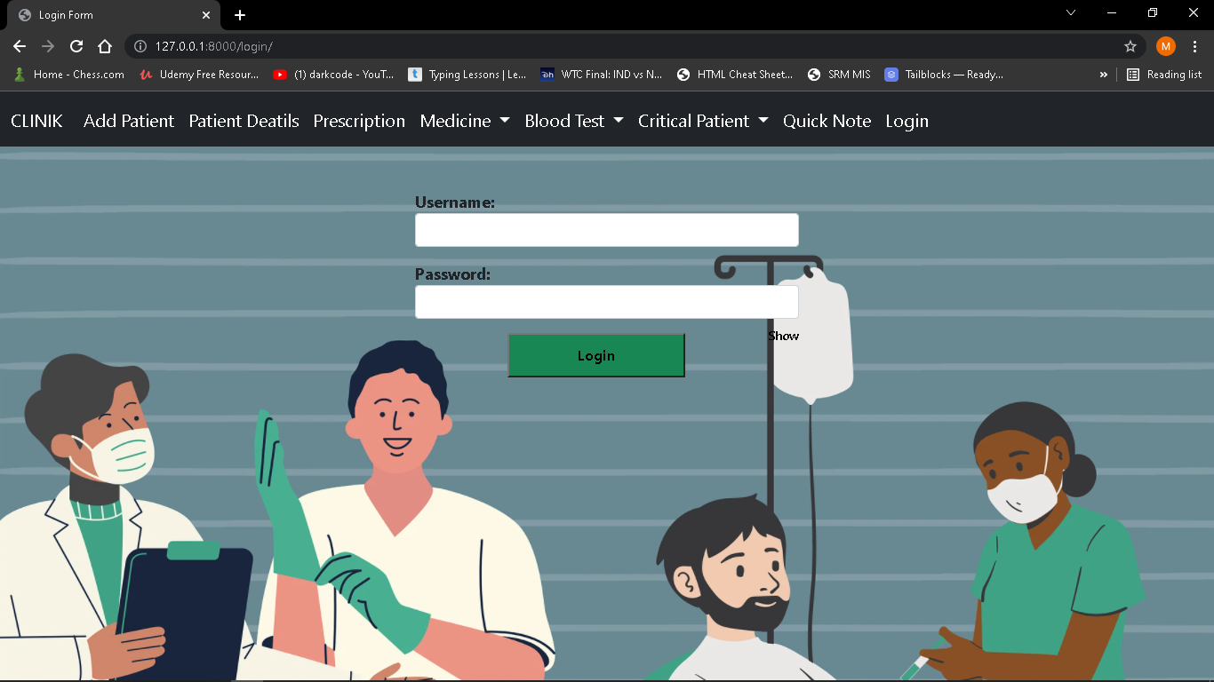

**2.Add Patient**

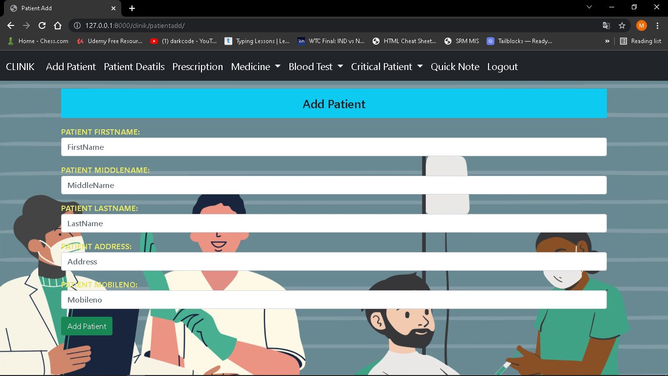

**3.Patientdetails**

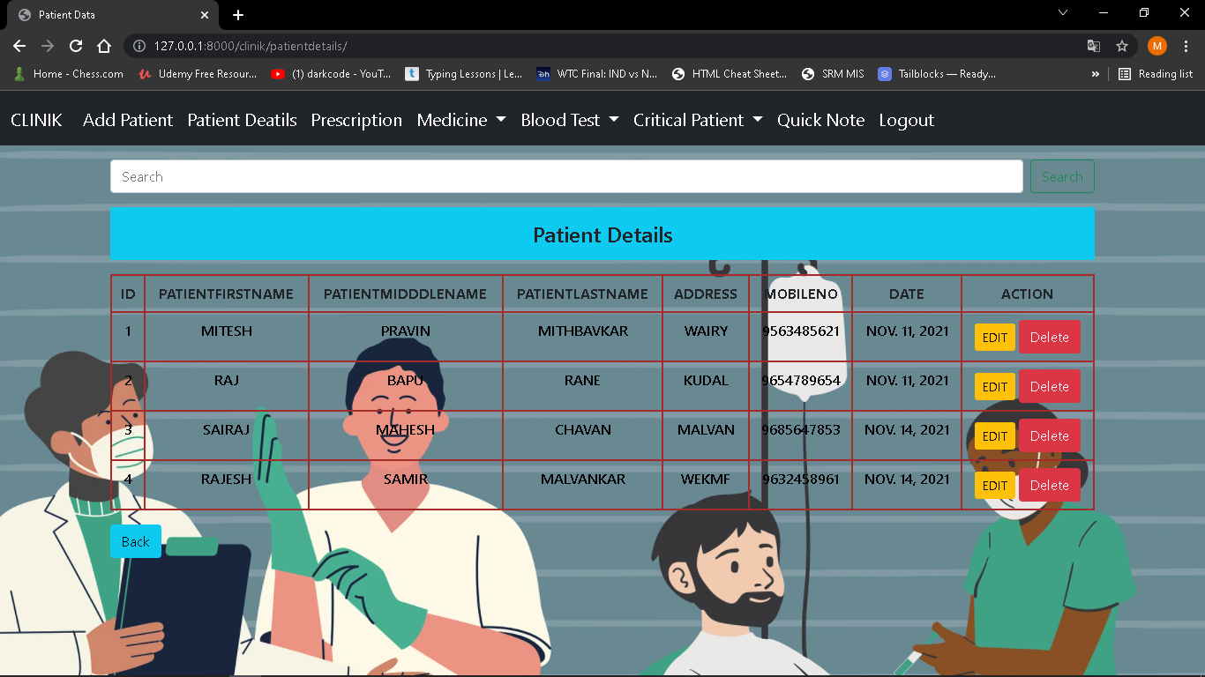

**4.Add medicine**

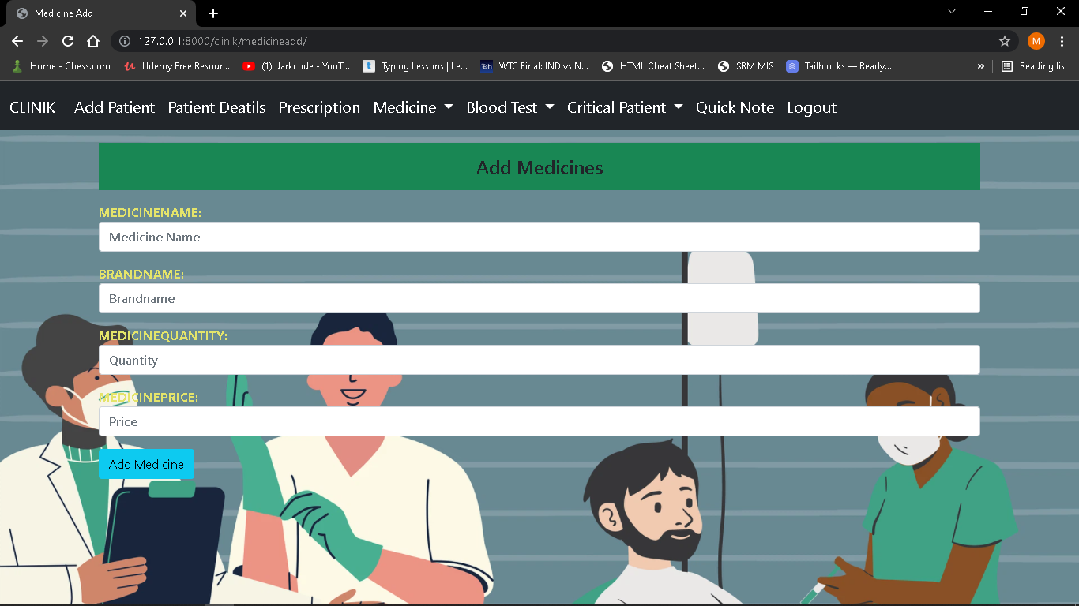

**5.Medicine Information**

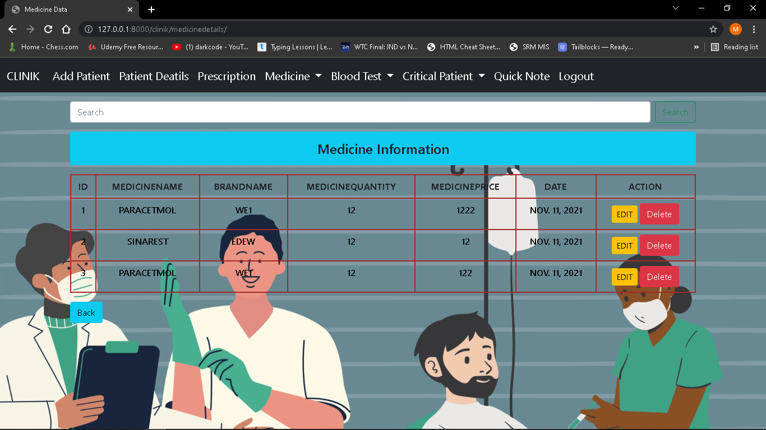

**6.Blood Test**

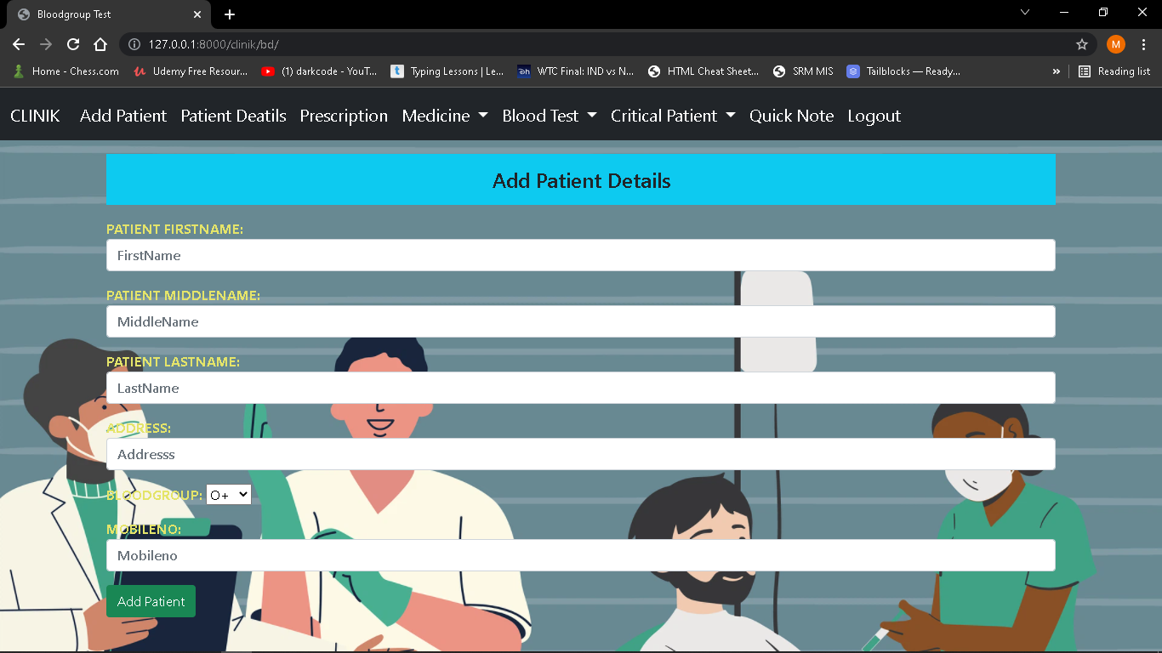

7**.Test Report**

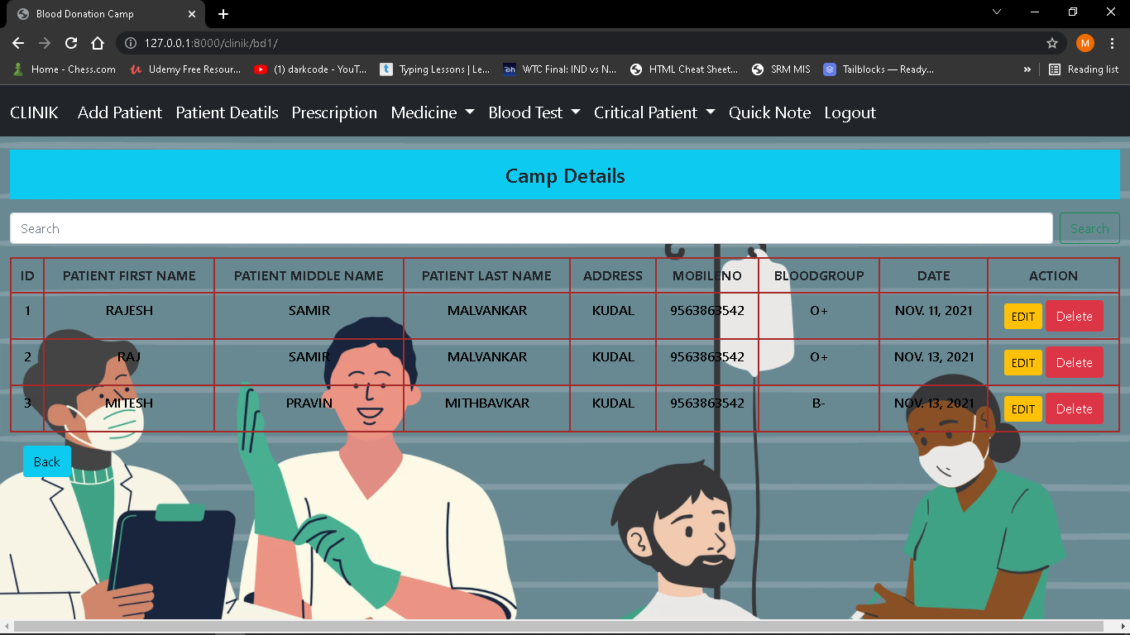

**8.Add Critical Patient**

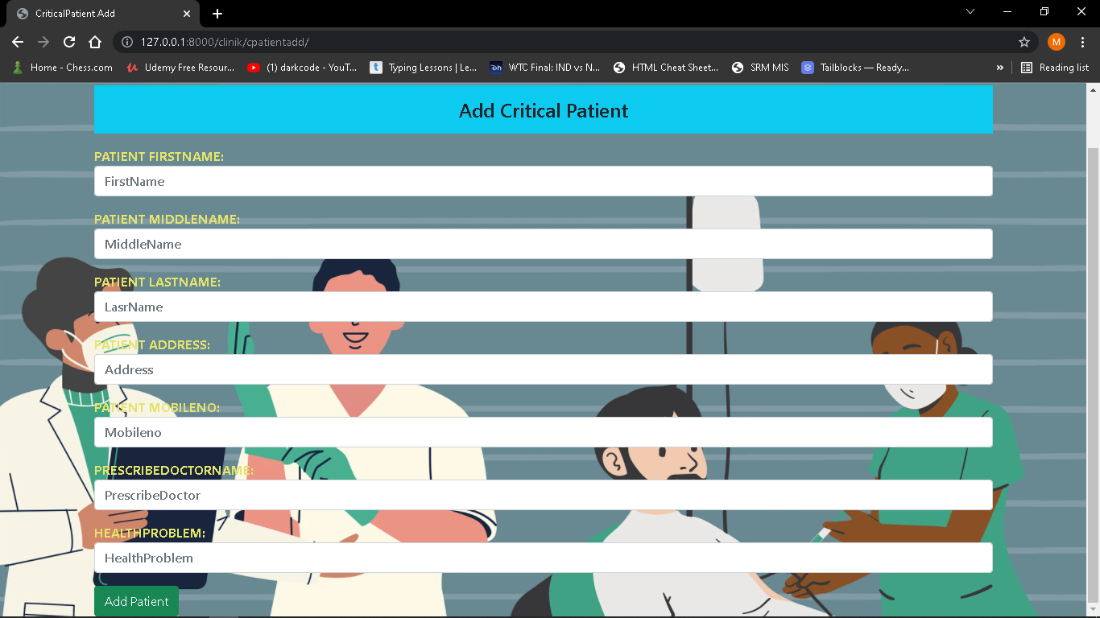

**9.Critical Patient Details**

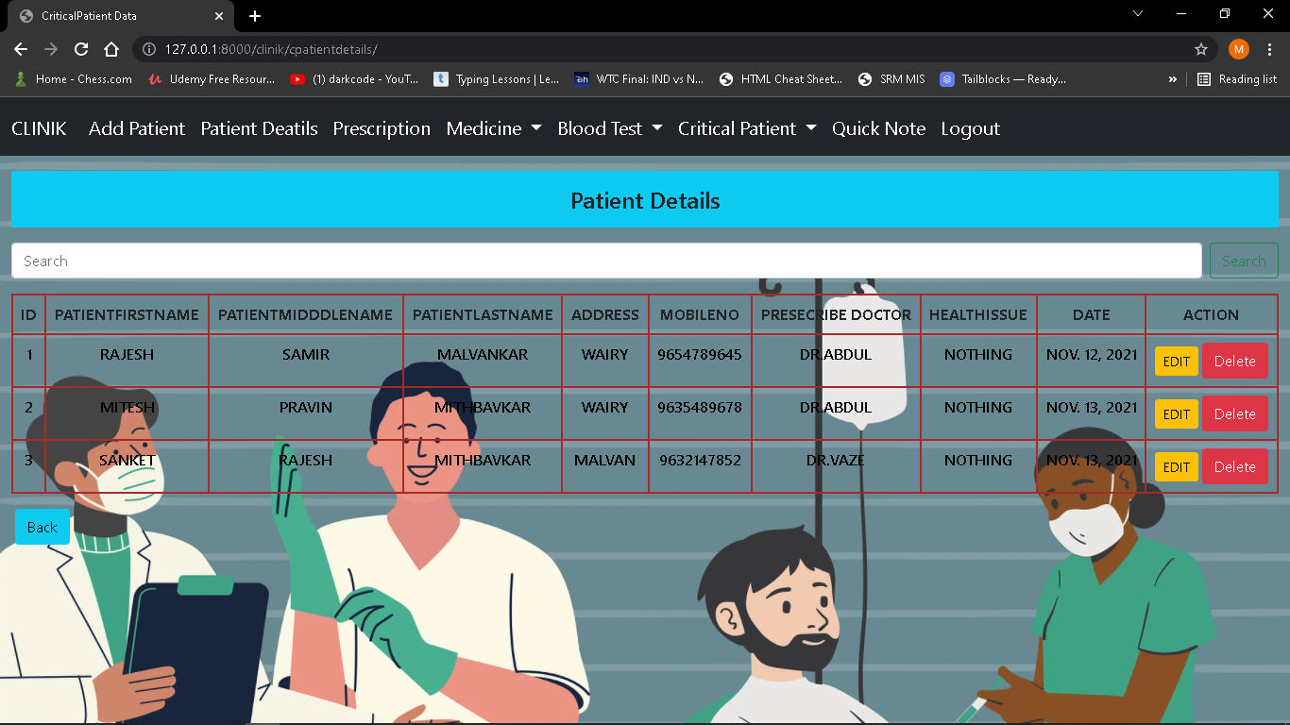

**10.Notes Details**

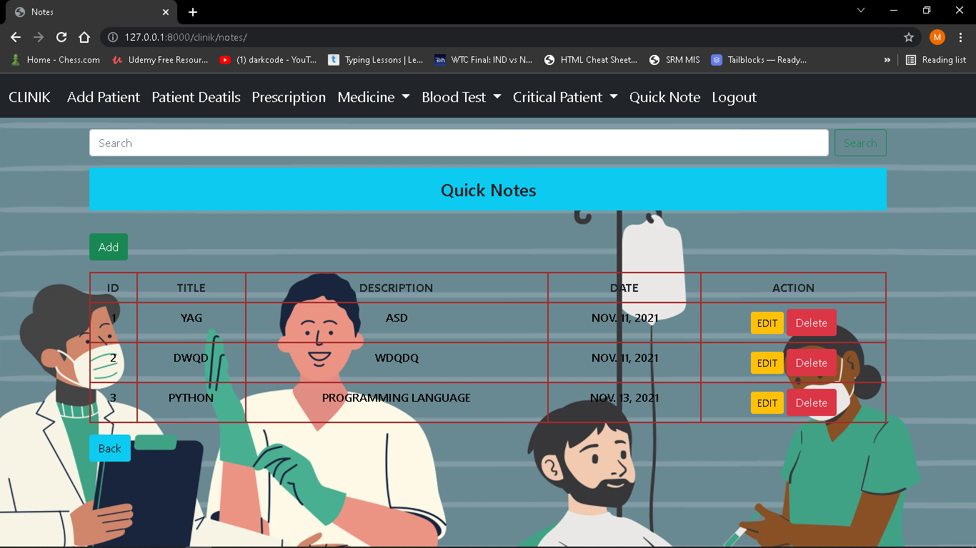

**11.Add Notes**

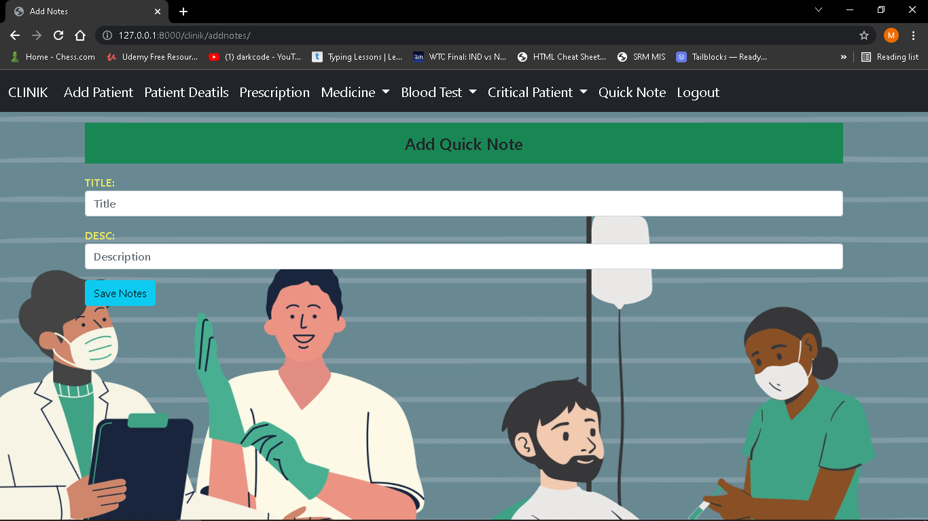

**12.Prescription add**

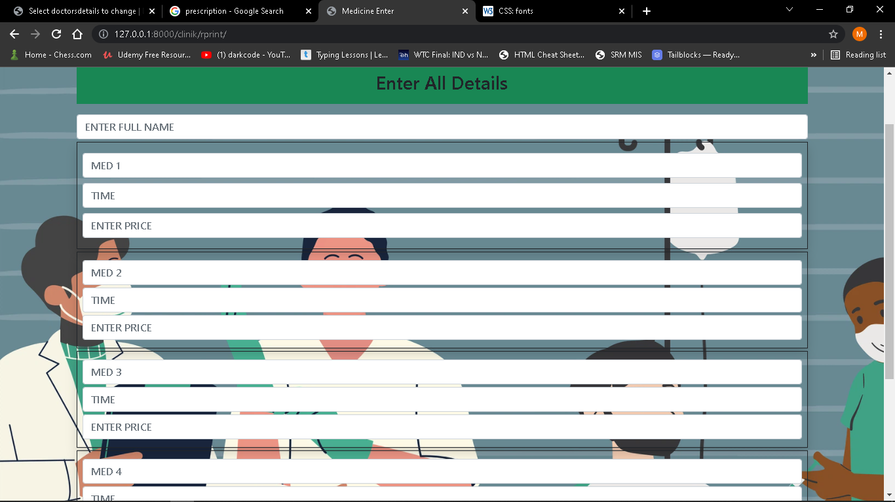

**13.Receipt**

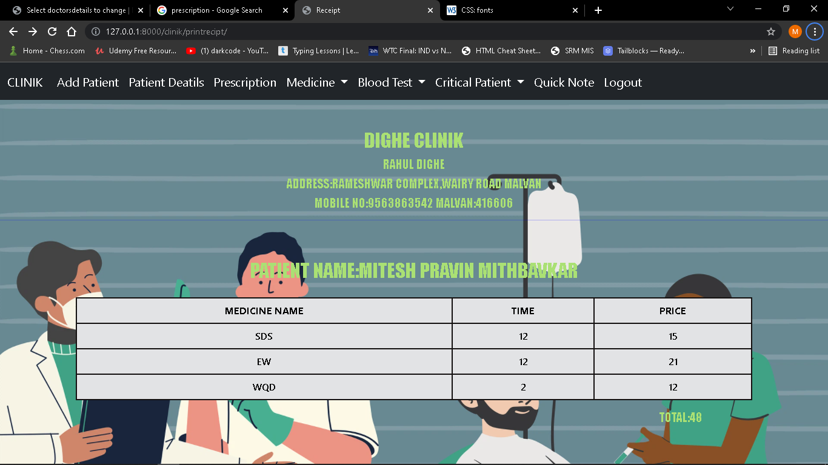

**CONCLUSION AND FUTURE SCOPE**

**Future Enhancements**

* + **I will add the feature for patients and doctors about sending and receiving reports on given condition of patients.**
  + **I will try to create advance report and prescription.**
  + **I will also try to make the GUI more responsive and easier for hospital staff and patients.**

**REFERENCES**

**URL Reference:**

* [**www.youtube.com**](http://www.youtube.com)
* [**www.w3school.com**](http://www.w3school.com)
* [**www.stackoverflow.com**](http://www.stackoverflow.com)